AI訓練模型5.08

我在做這些東西和學校的作業的這段時間裡，又在思考了一下所謂的神經運算到底是怎麼運作的，我最後大概有想清楚了（雖然真的只是自己想而已），就是所謂的AI模型訓練，就是把一個空白的神經模型，依照我丟給他的資料，讓他依照他的模型和我幫他調整的參數，自己去對應到我的那個資料的走勢，一旦找到可以相符的資料就繼續訓練下去，但如果找不到可以相符的資料，應該就是代表lose值變得需要觀察，需要再重新訓練的意思吧，不知道我這樣理解的對不對。

但我還是想不明白的事是，之前一直不知道該怎麼說，現在梳理想法後大概知道了，就是假如本來的想法是要做二分法的話，activation應該會用sigmoid，但假如說用了別的activation的話會有機會得到更低更小的val_loss嗎，如果有機會的話我應該要遵從較低的val_loss選擇另一個activation來用，還是要繼續用sigmoid，其他函數也同裡想問，然後依照我上面對於訓練模型的說法來看的話，我腦袋一直感覺有個結打不開，就是那個模型是輸出了什麼東西去配合activation來做變化，進而和資料檔案進行比對，雖然知道sigmoid會輸出0或1之間，但是輸入到sigmoid函數的資料對於那個模型而言到底是什麼我一直想不通，最後val_loss這些值是如何轉化的出來的也有點好奇，當然如果想不通的話還是能單純依照val_loss的高低去配對適合的activation來用，但時間就可能會拉的很長，而且我做的也會沒什麼實感

想分享的是沒想到最近學校的期末作業真的讓我需要利用終端機創造一個虛擬環境，在裡面安裝東西以便利用。

以下正題：

這次我參考的程式是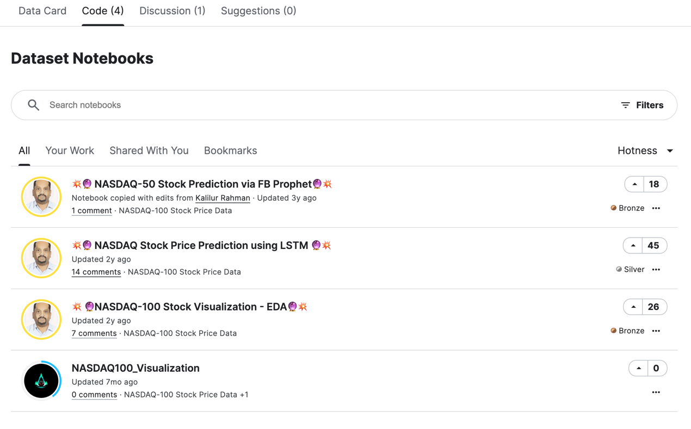中最下面那個NASDAQ100_Visualzation所寫的程式，因為其他的在編譯的時候都無法正常編譯，只有他的可以，但因為他本身沒有所謂的激活函數，所以我只能求助，看看是不是真的沒在裡面，還是我沒看到，最後知道是真的沒在裡面，就只能自己加進去用了

* 程式：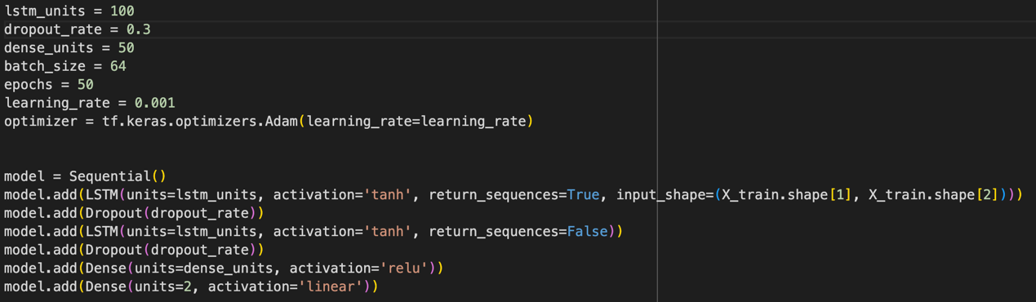

Lstm_units = 100

Dropout_rate = 0.3

Dense_units = 50

Batch_size = 64

Epochs = 50

Learning_rate = 0.001

LSTM-1 = tanh

LSTM-2 = tanh

Dense-1 = relu

Dense-2 = linear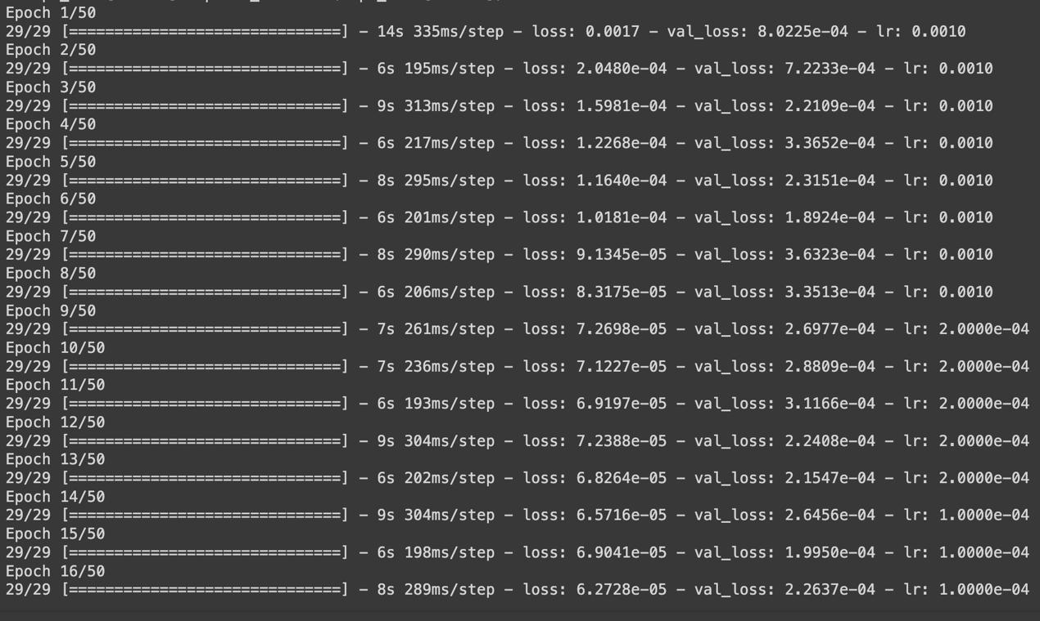

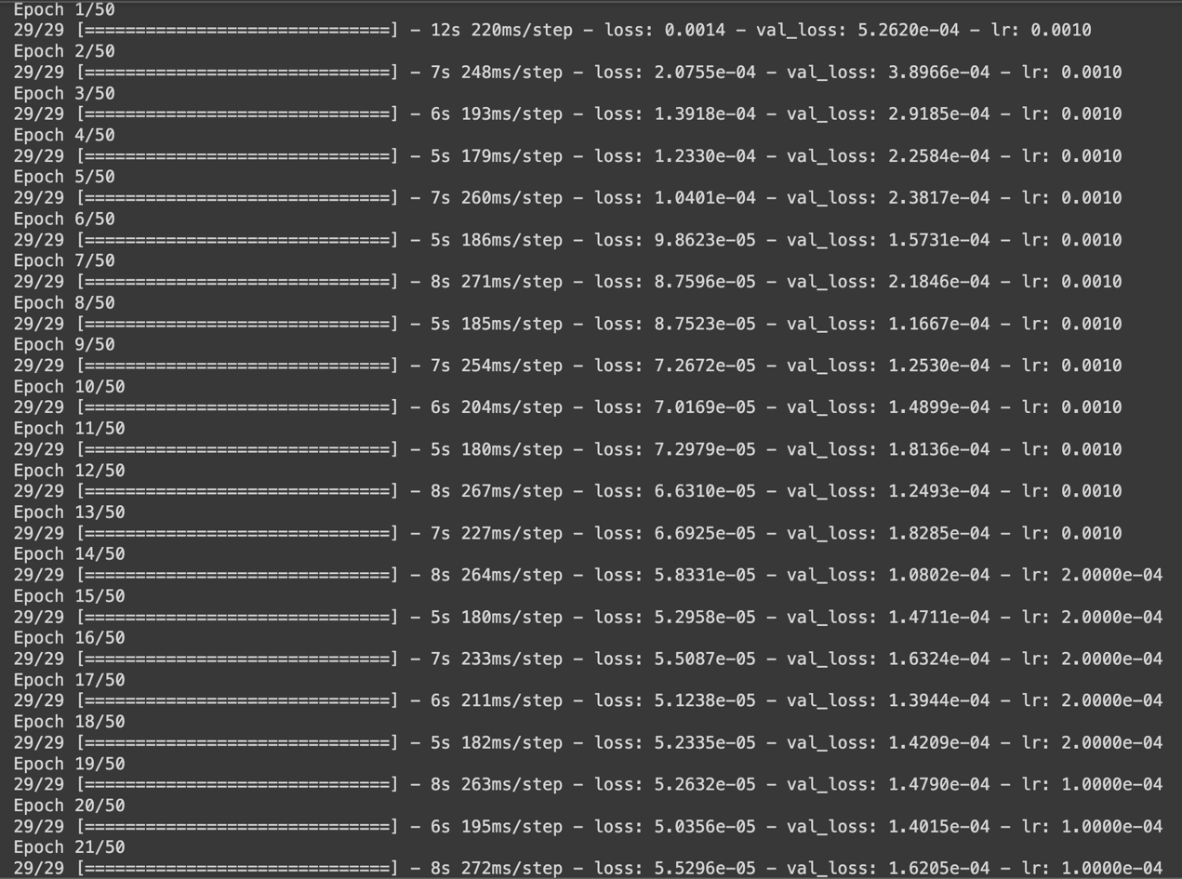

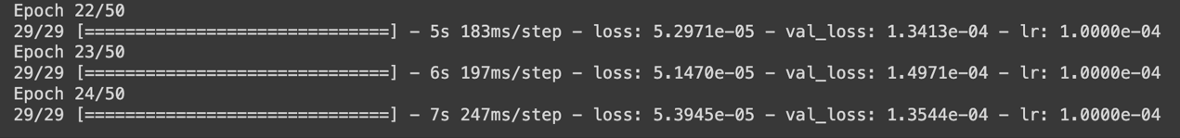

第一次看到1.2345e的數值還以為怎麼都這麼大，上網查後才知道他比原本的0.001還要小，雖然說他兩次訓練的損失都已經非常的小了，但因為他還是因為沒有什麼訓練效果（感覺上不會再變得更小了，或是相對來說有可能還變更大），所以還不到50在中途就被暫停了。

Lstm_units = 100

Dropout_rate = 0.3

Dense_units = 50

Batch_size = 64

Epochs = 50

Learning_rate = 0.001

LSTM-1 = tanh

LSTM-2 = relu

Dense-1 = relu

Dense-2 = linear

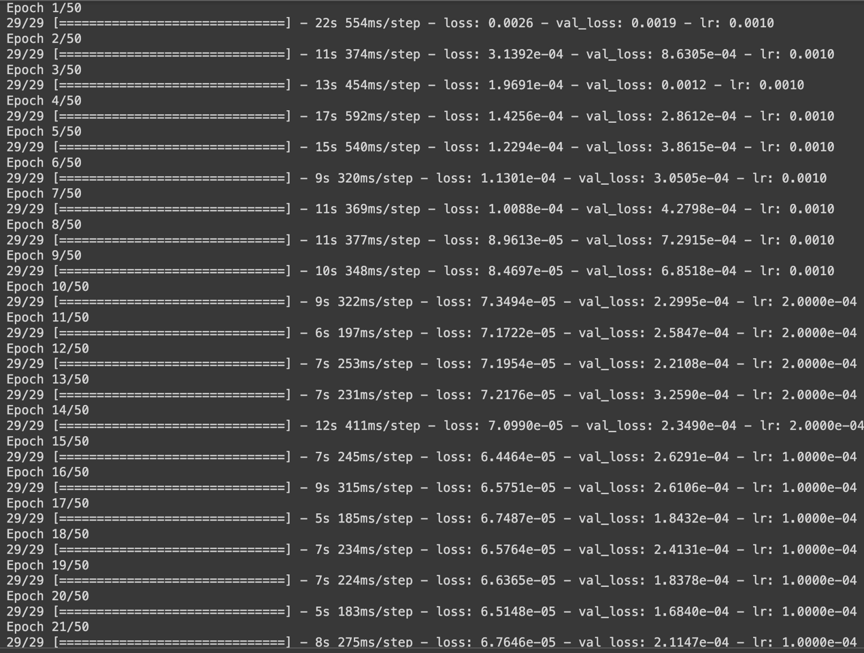

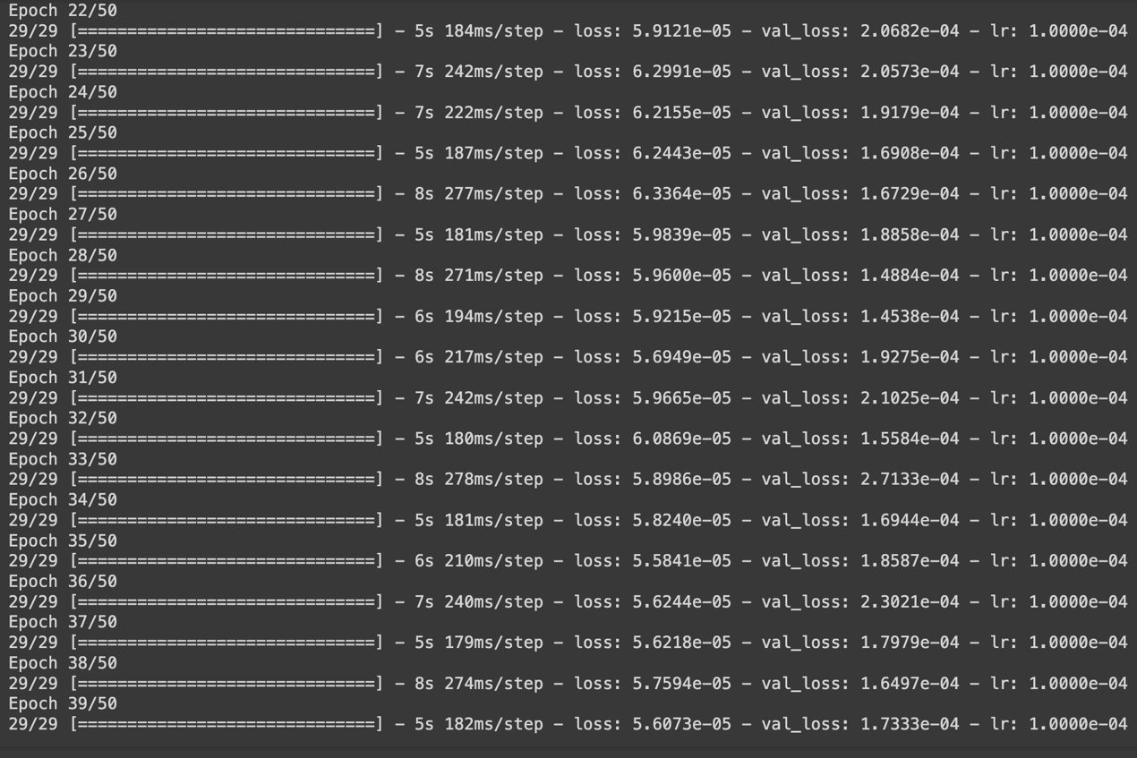

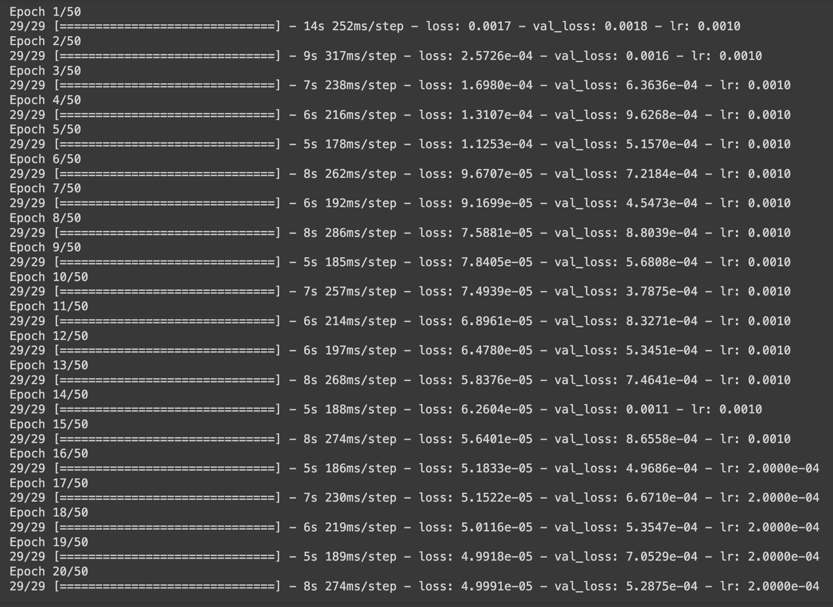

Lstm_units = 100

Dropout_rate = 0.3

Dense_units = 50

Batch_size = 64

Epochs = 50

Learning_rate = 0.001

LSTM-1 = relu

LSTM-2 = relu

Dense-1 = relu

Dense-2 = linear

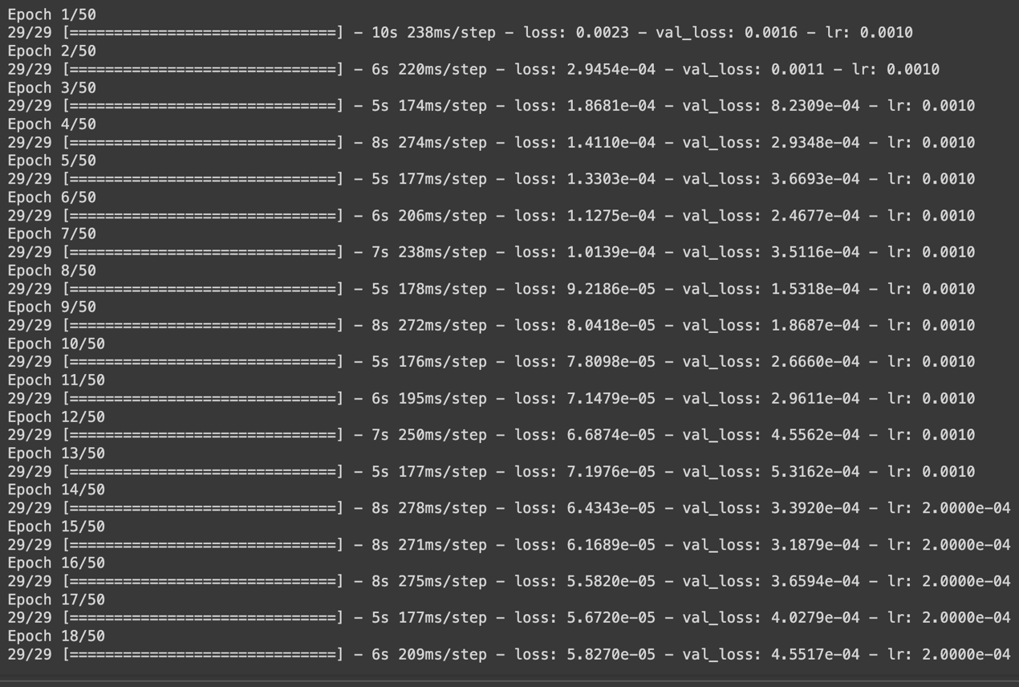

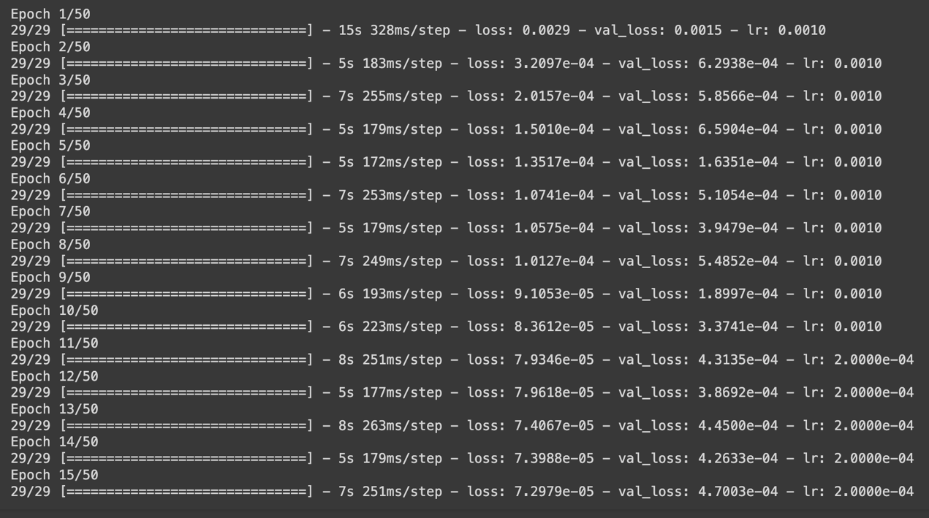

Lstm_units = 100

Dropout_rate = 0.3

Dense_units = 50

Batch_size = 64

Epochs = 50

Learning_rate = 0.001

LSTM-1 = relu

LSTM-2 = tanh

Dense-1 = relu

Dense-2 = linear

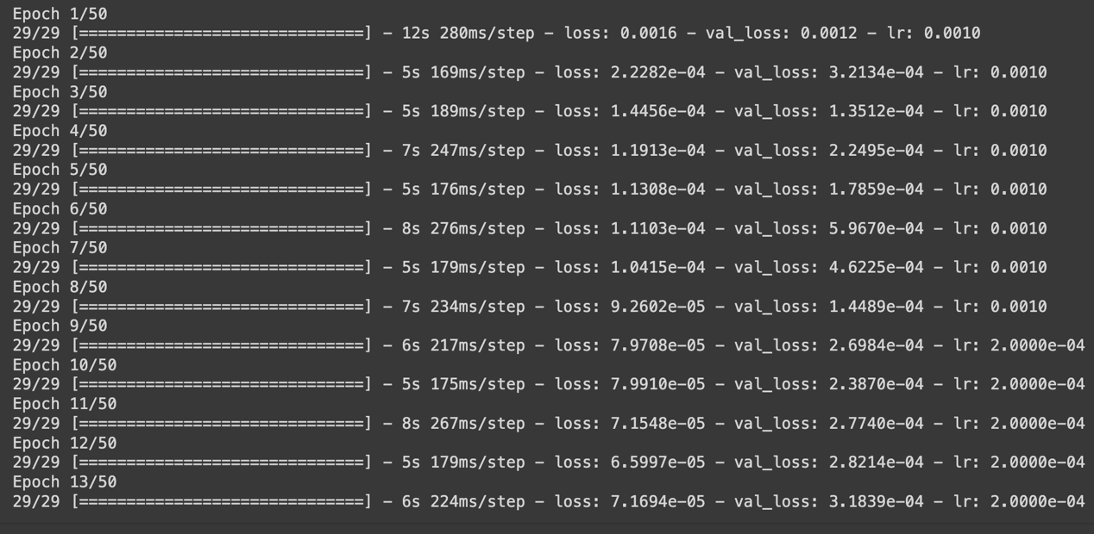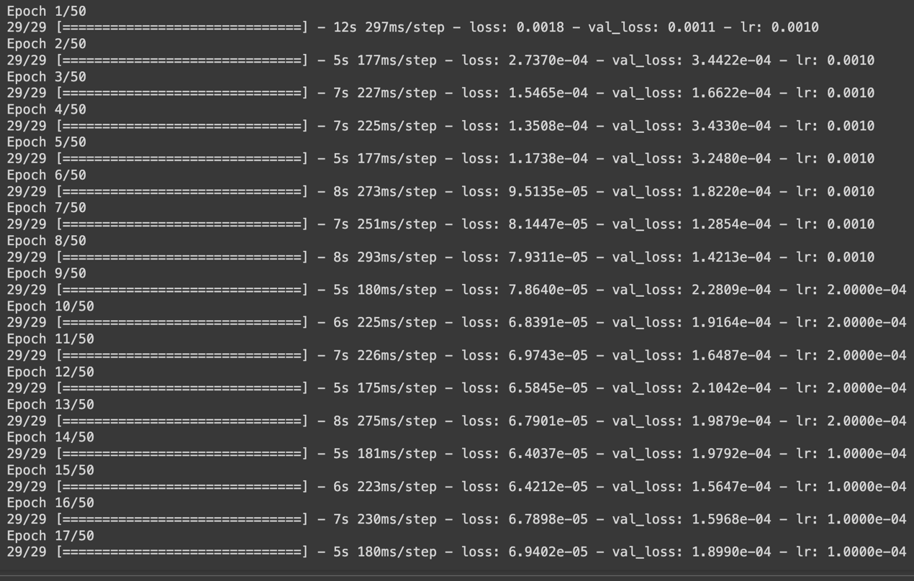

Lstm_units = 100

Dropout_rate = 0.3

Dense_units = 50

Batch_size = 64

Epochs = 50

Learning_rate = 0.001

LSTM-1 = tanh

LSTM-2 = sigmoid

Dense-1 = relu

Dense-2 = linear

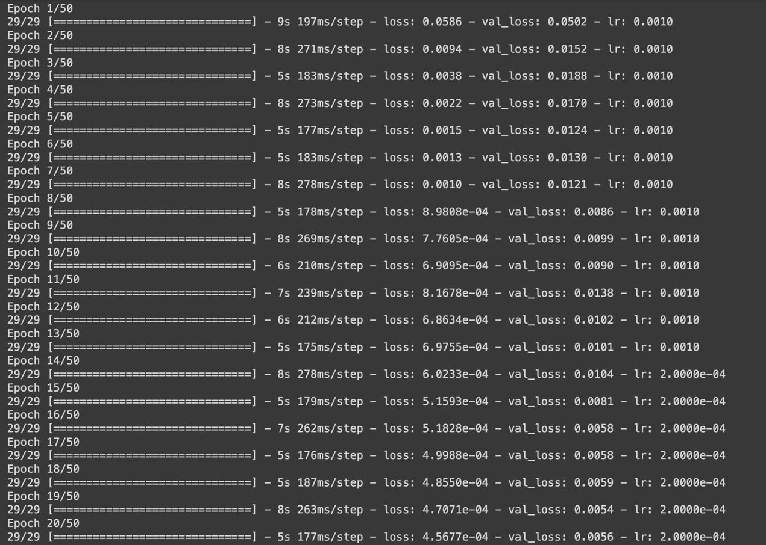

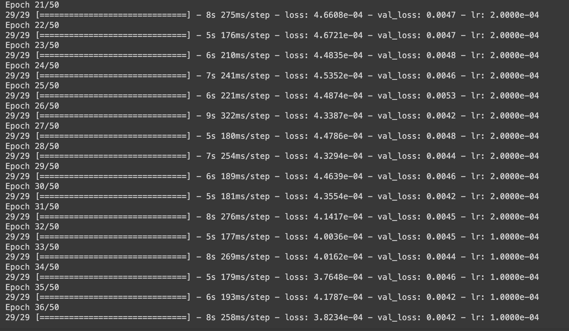

Lstm_units = 100

Dropout_rate = 0.3

Dense_units = 50

Batch_size = 64

Epochs = 50

Learning_rate = 0.001

LSTM-1 = sigmoid

LSTM-2 = tanh

Dense-1 = relu

Dense-2 = linear

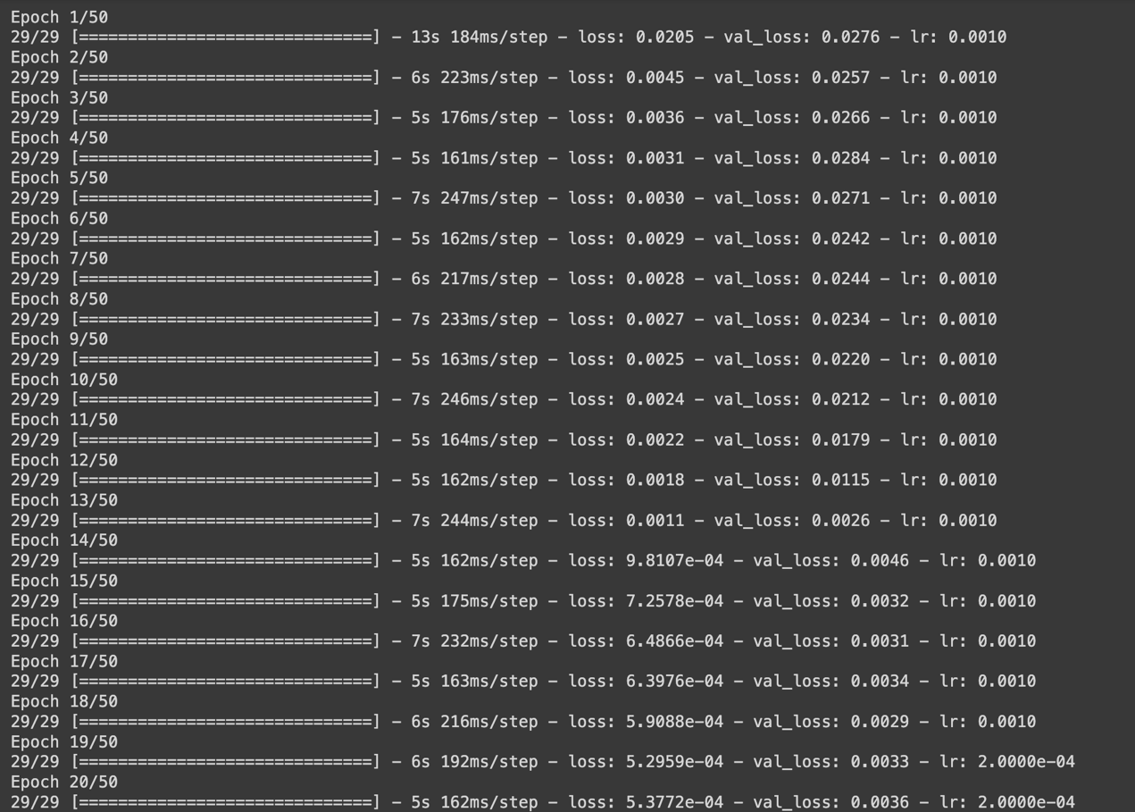

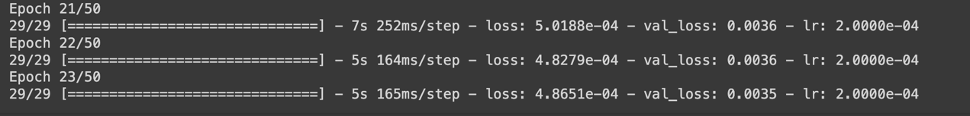

最後我就先用看起來比較穩定且比較好的兩個LSTM的激活函數都是tanh來進行接下來的訓練

Lstm_units = 100

Dropout_rate = 0.3

Dense_units = 50

Batch_size = 64

Epochs = 50

Learning_rate = 0.001

Dense-1 = relu

Dense-2 = linear

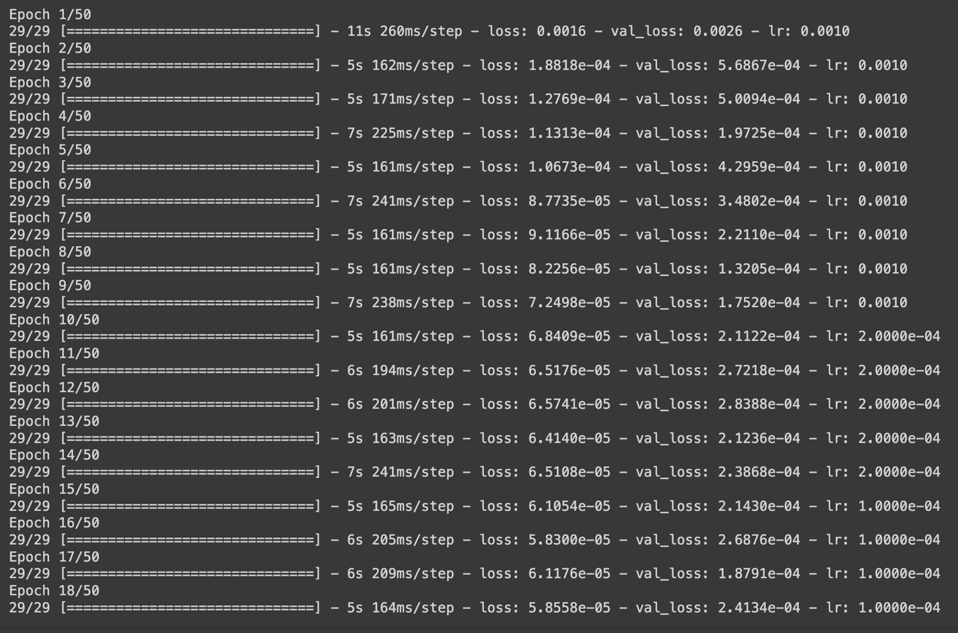

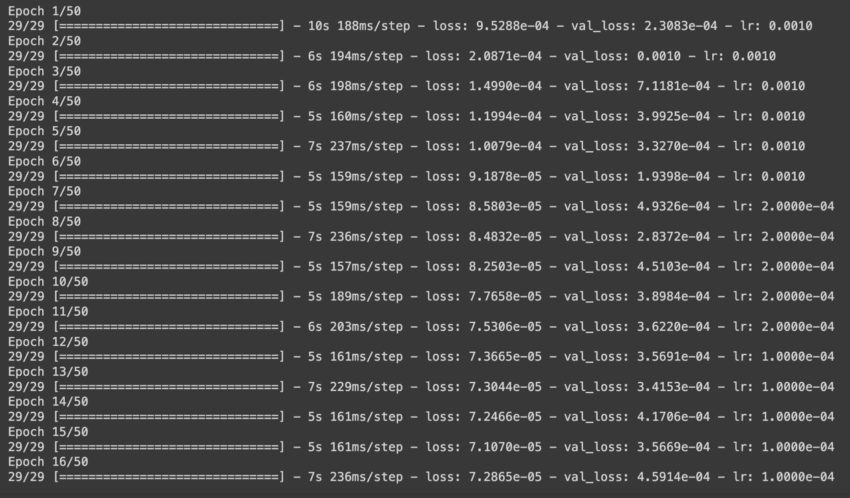

Lstm_units = 100

Dropout_rate = 0.3

Dense_units = 50

Batch_size = 64

Epochs = 50

Learning_rate = 0.001

Dense-1 = sigmoid

Dense-2 = linear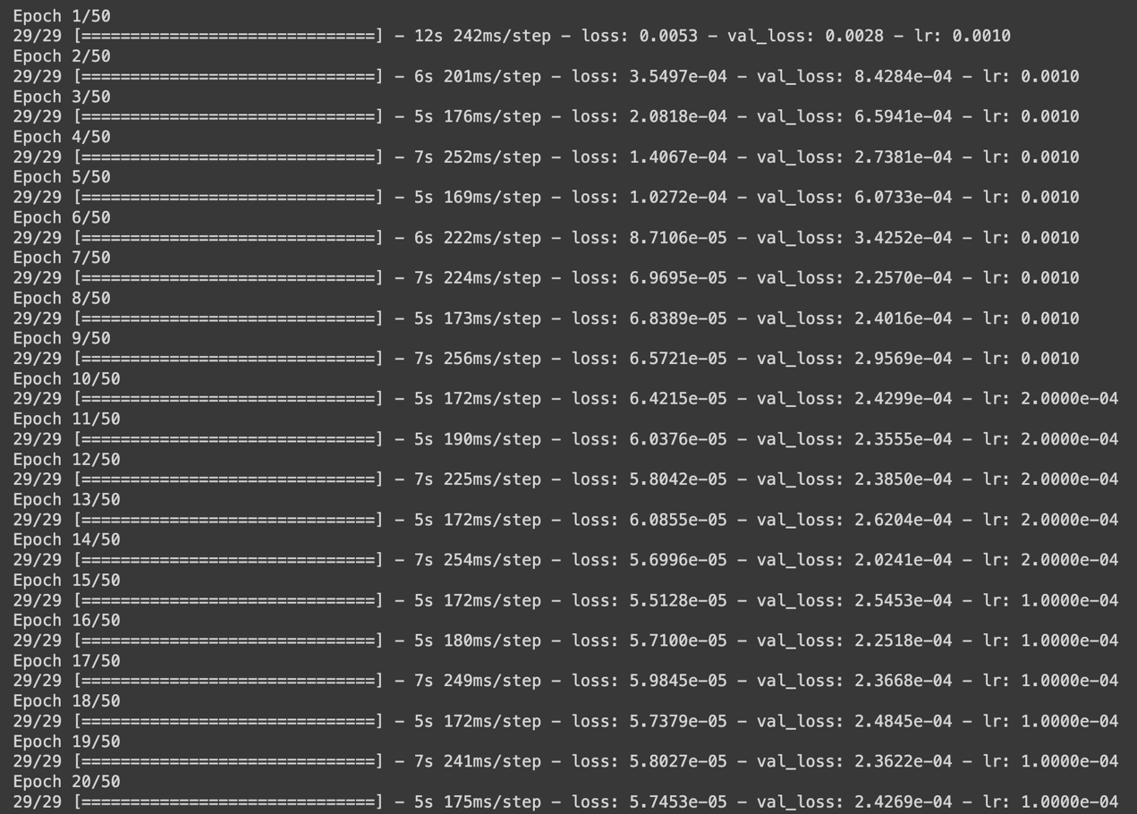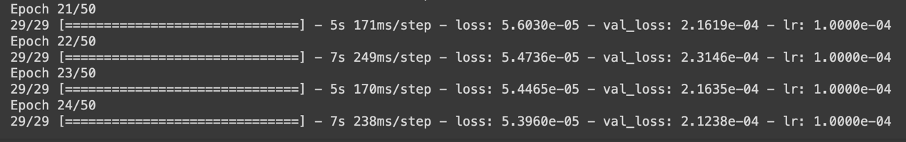

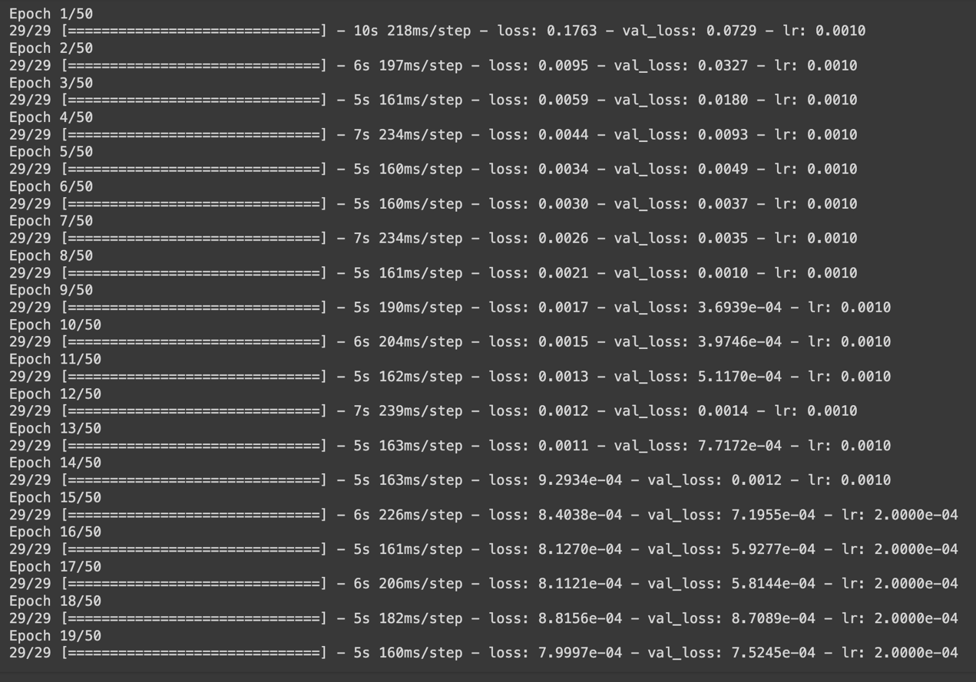

Lstm_units = 100

Dropout_rate = 0.3

Dense_units = 50

Batch_size = 64

Epochs = 50

Learning_rate = 0.001

Dense-1 = LeakyReLU

Dense-2 = linear

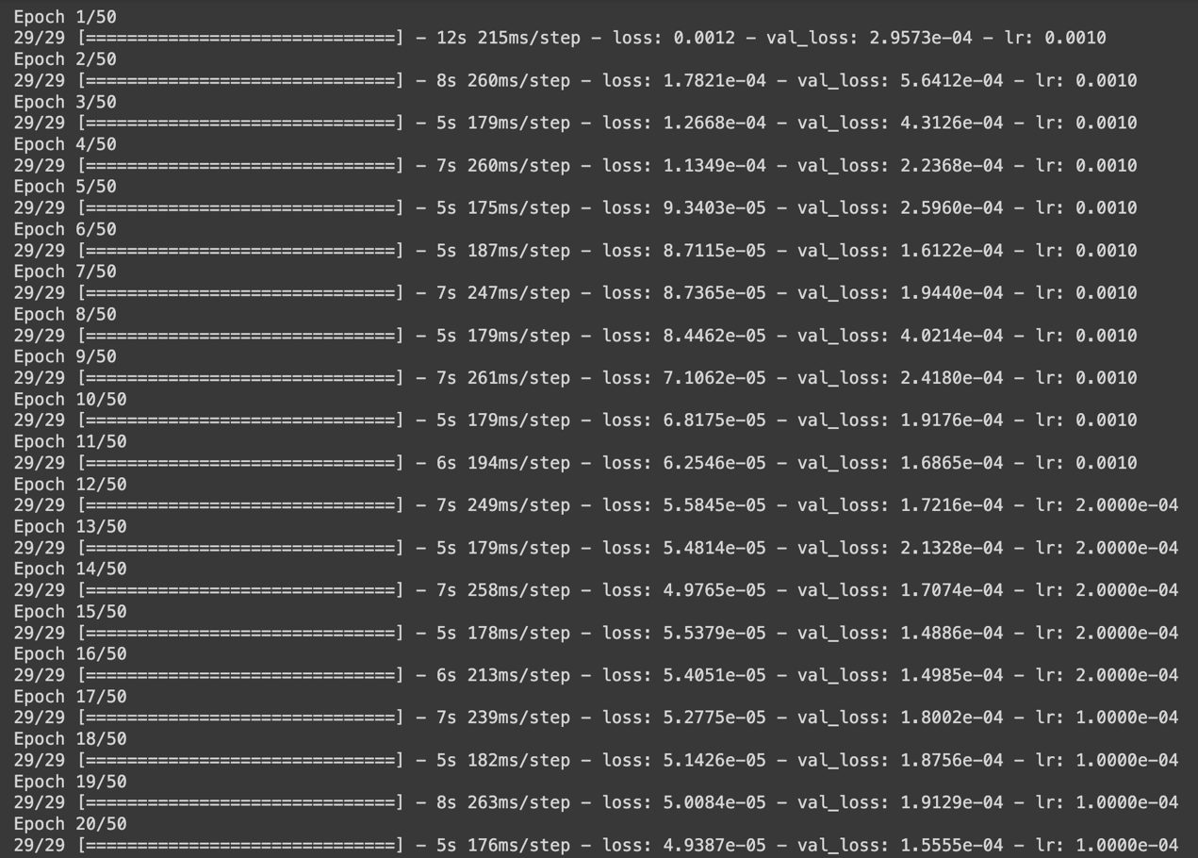 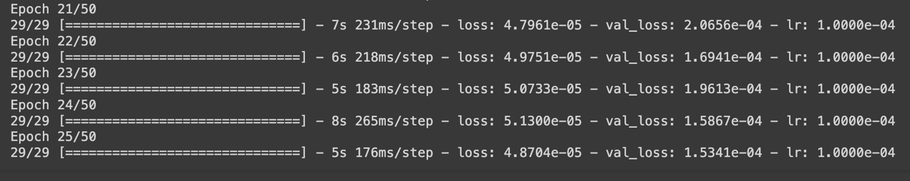

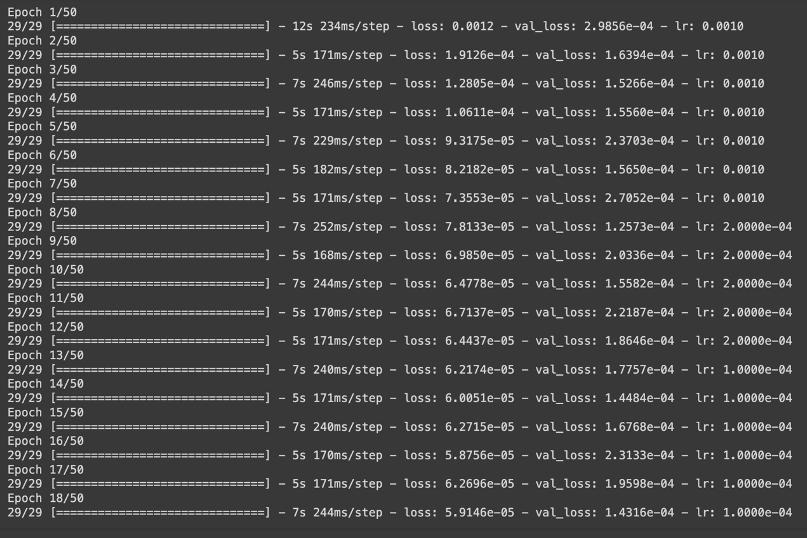

Lstm_units = 100

Dropout_rate = 0.3

Dense_units = 50

Batch_size = 64

Epochs = 50

Learning_rate = 0.001

Dense-1 = PReLU

Dense-2 = linear

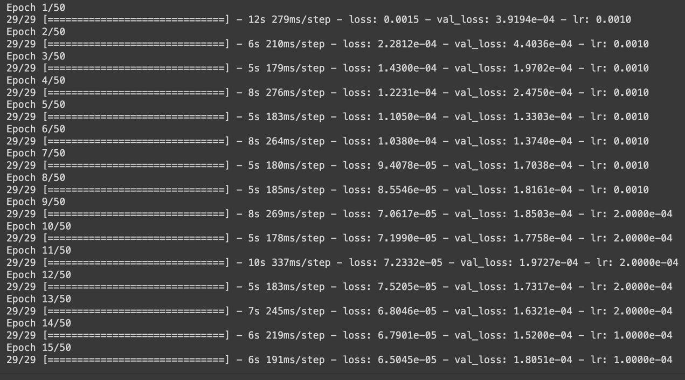

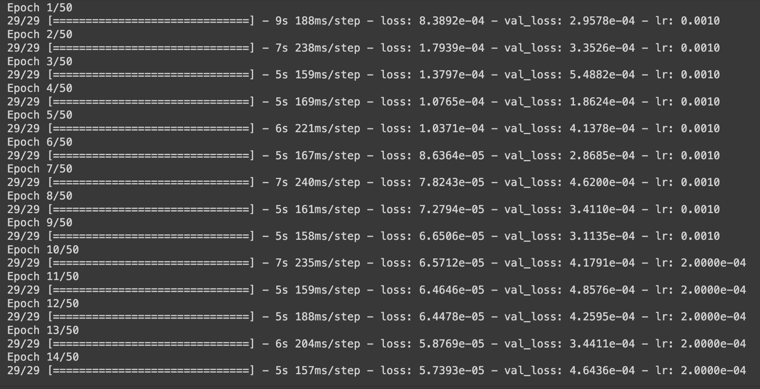

Lstm_units = 100

Dropout_rate = 0.3

Dense_units = 50

Batch_size = 64

Epochs = 50

Learning_rate = 0.001

Dense-1 = ELU

Dense-2 = linear

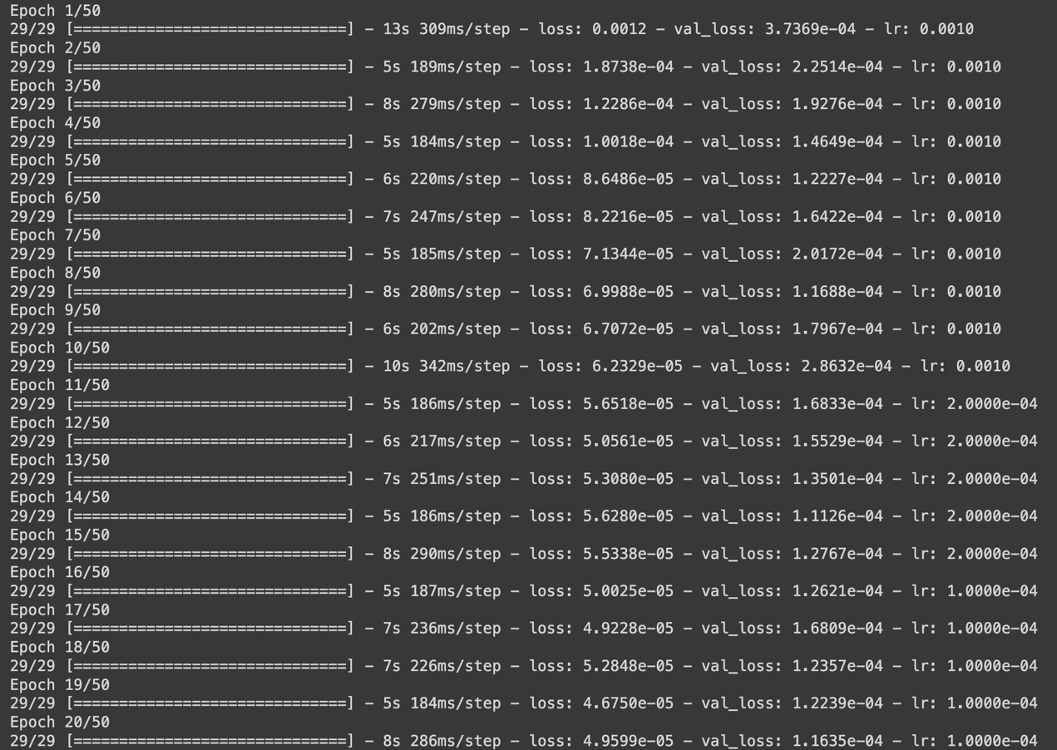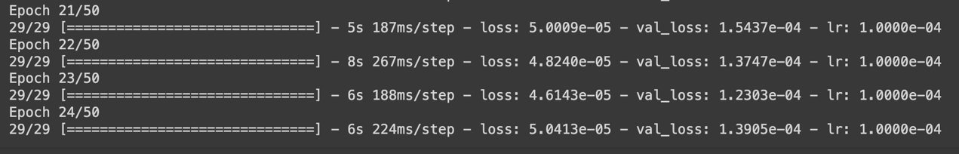

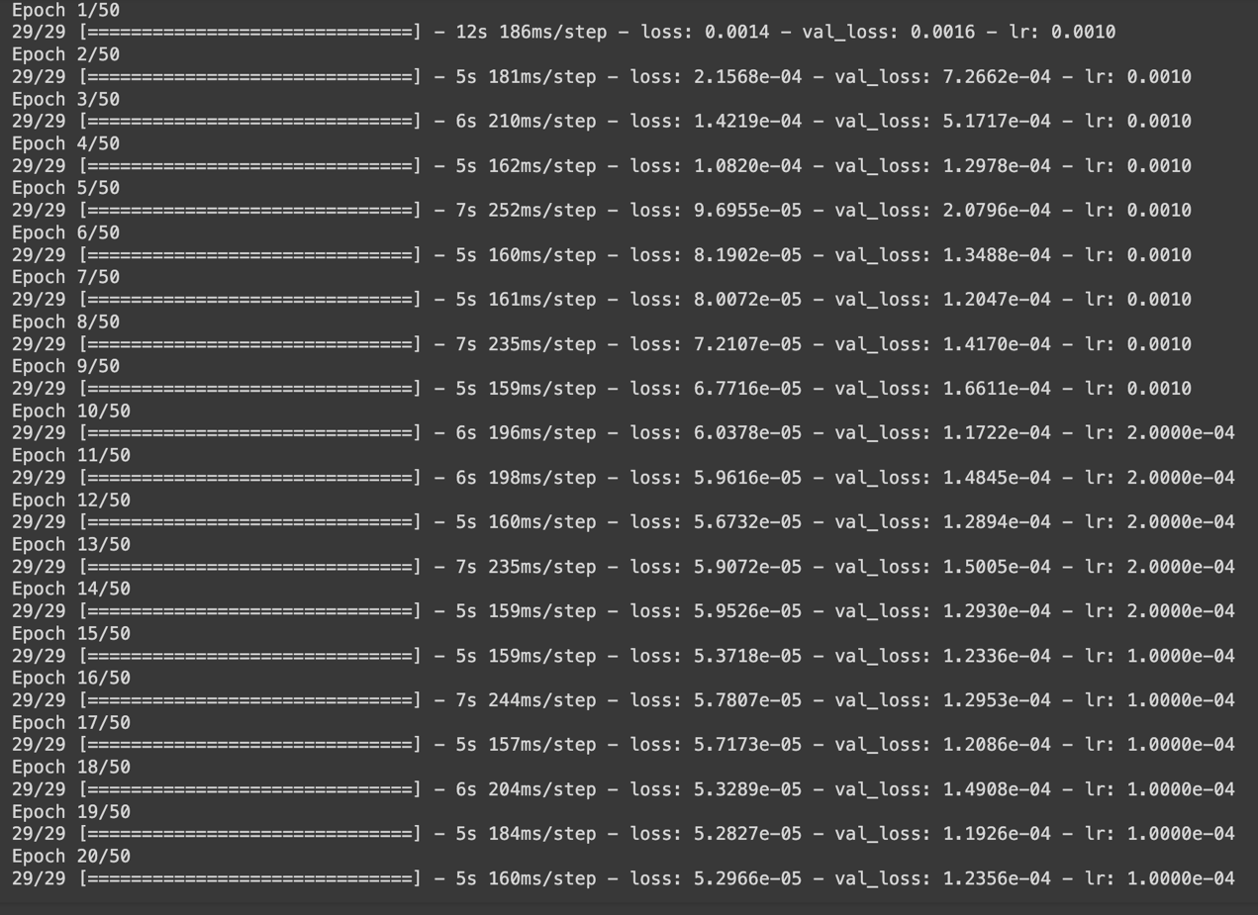

Lstm_units = 100

Dropout_rate = 0.3

Dense_units = 50

Batch_size = 64

Epochs = 50

Learning_rate = 0.001

Dense-1 = selu

Dense-2 = linear 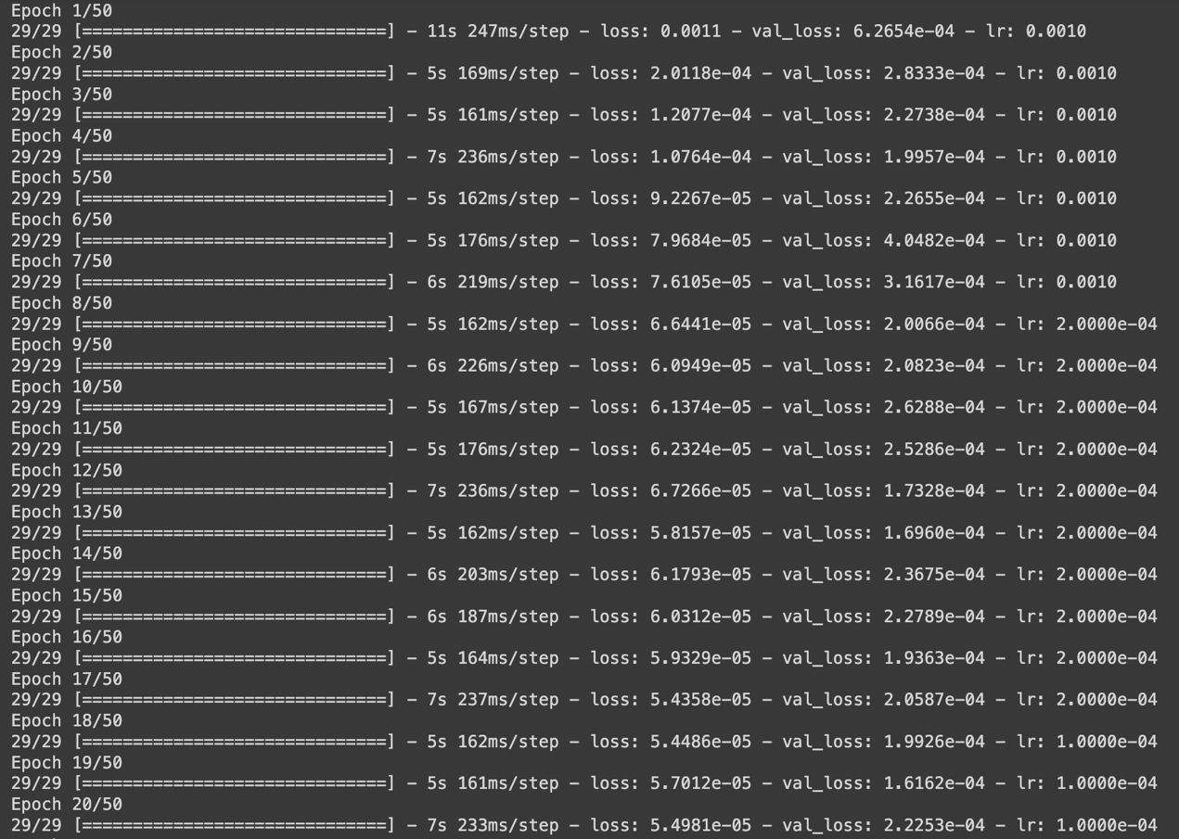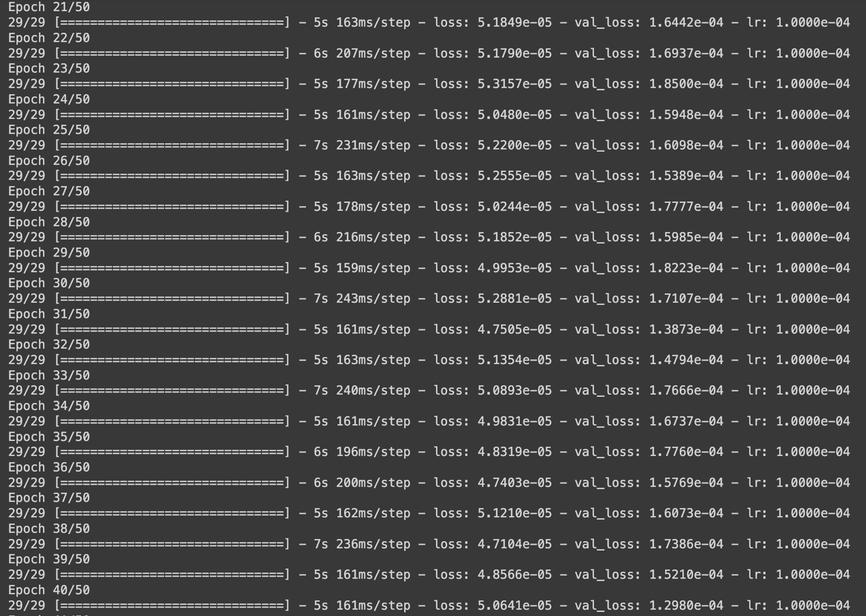

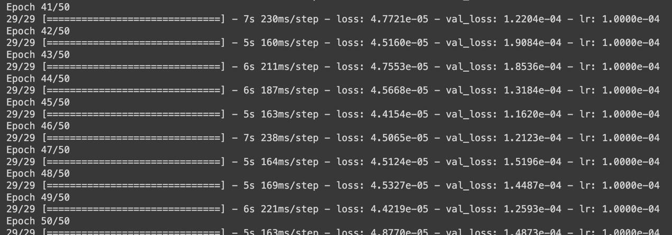 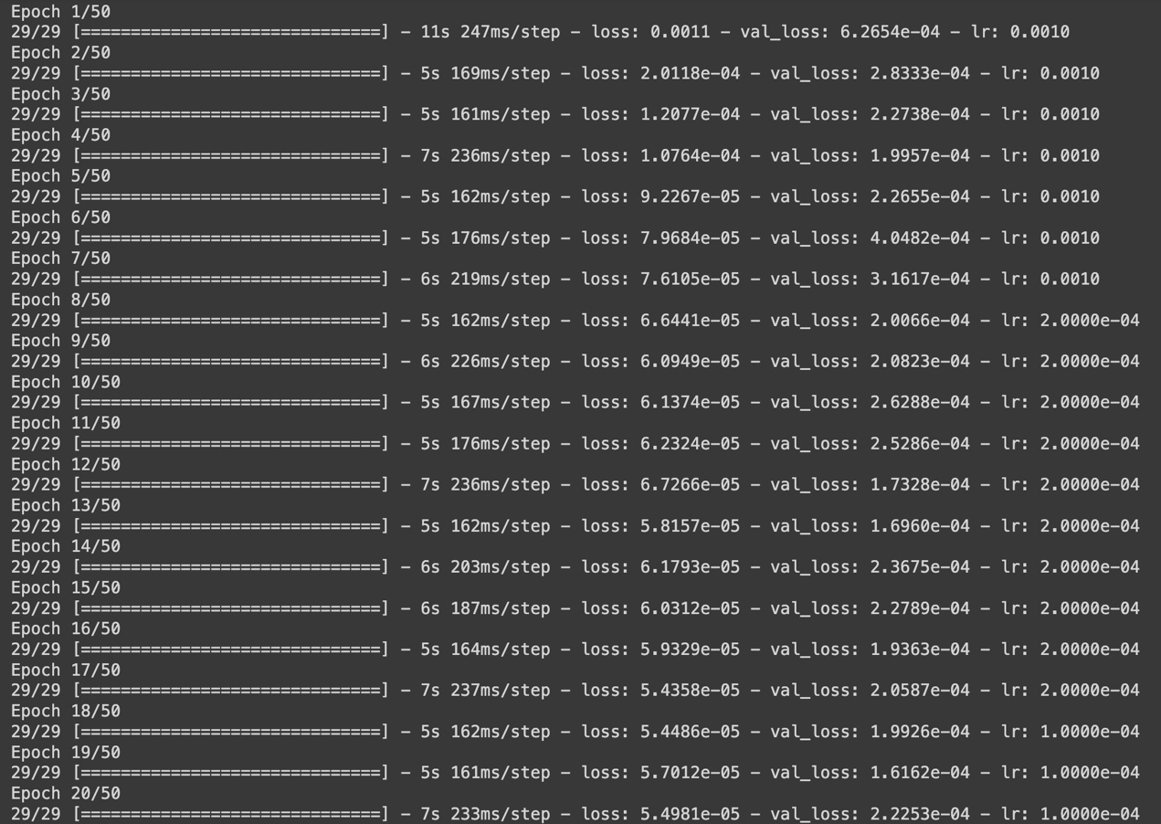

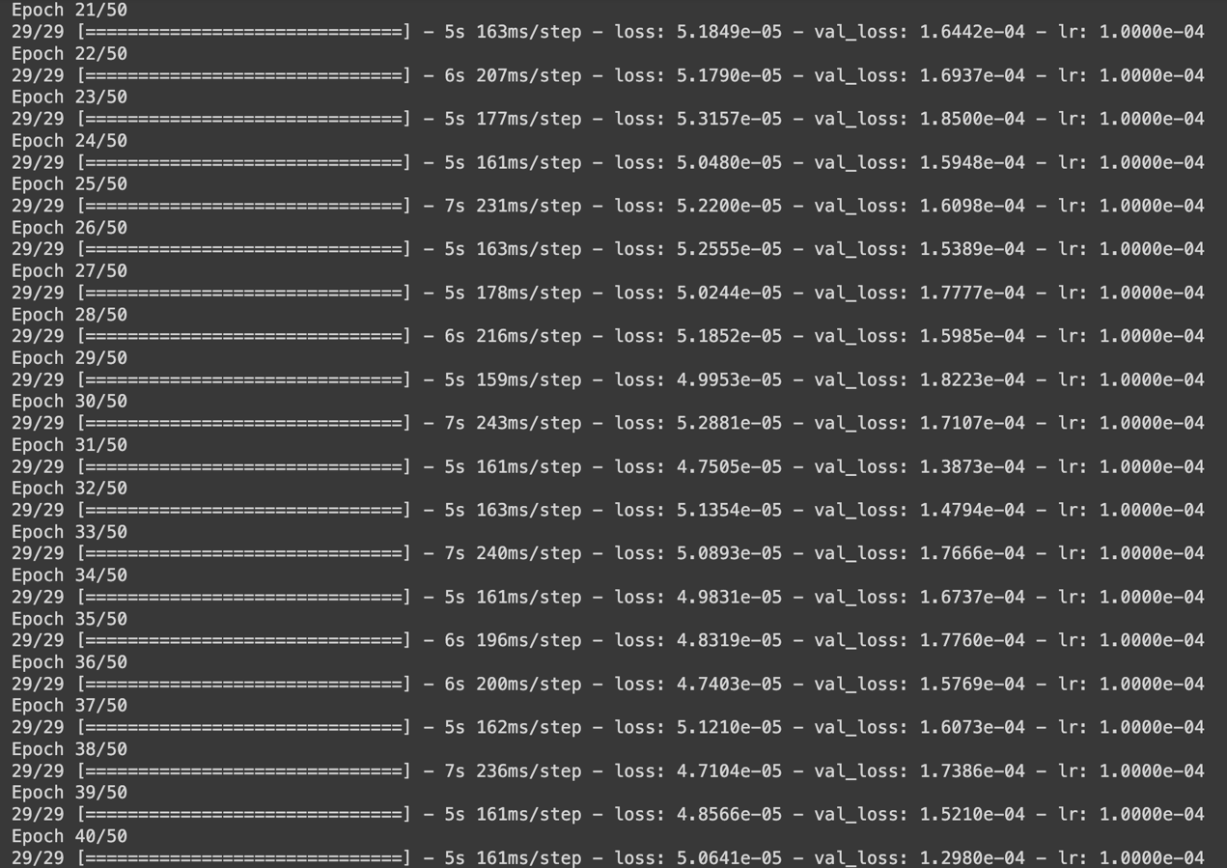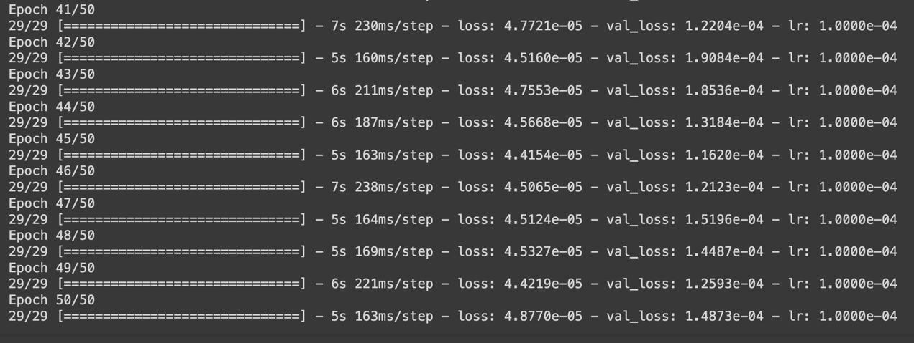

Lstm_units = 100

Dropout_rate = 0.3

Dense_units = 50

Batch_size = 64

Epochs = 50

Learning_rate = 0.001

Dense-1 = softmax

Dense-2 = linear

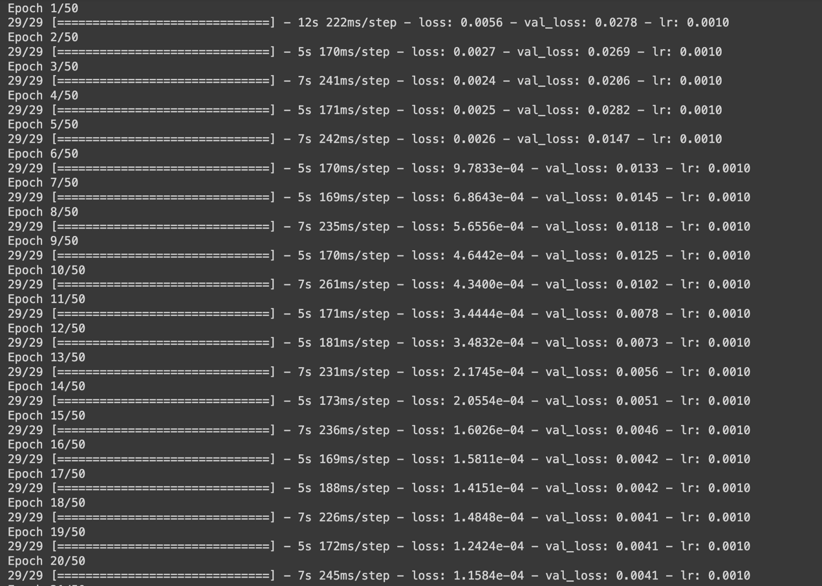

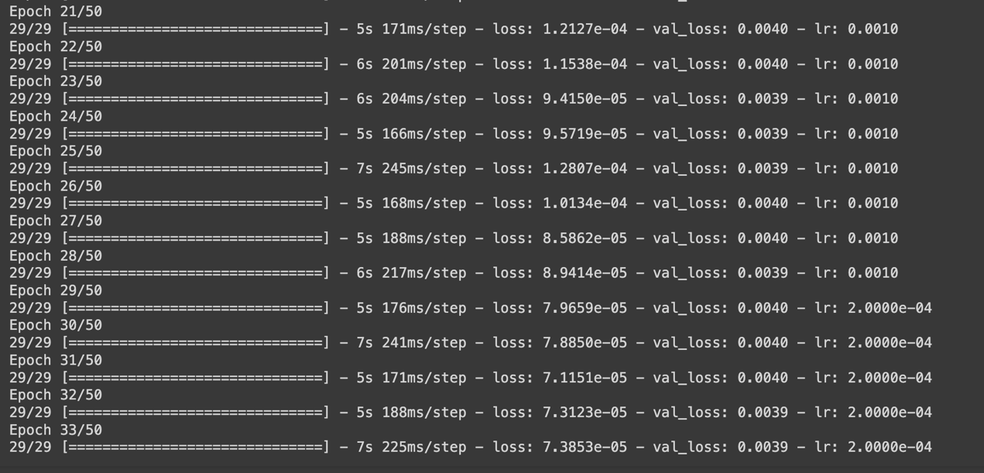 Lstm_units = 100

Dropout_rate = 0.3

Dense_units = 50

Batch_size = 64

Epochs = 50

Learning_rate = 0.001

Dense-1 = softplus

Dense-2 = linear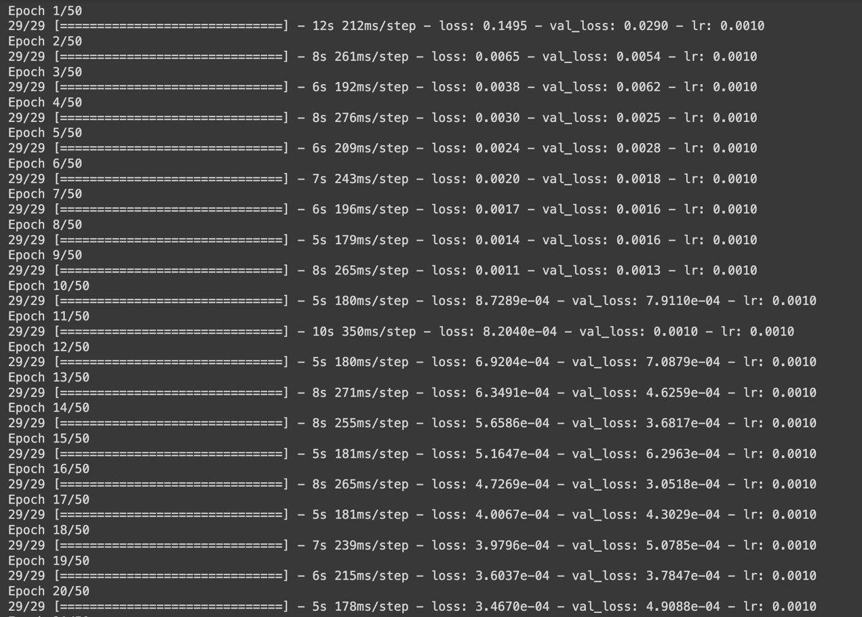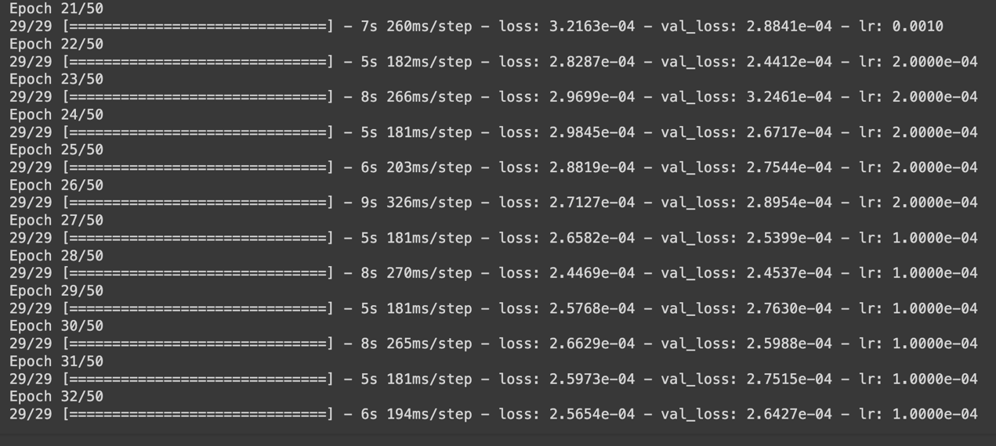 Lstm_units = 100

Dropout_rate = 0.3

Dense_units = 50

Batch_size = 64

Epochs = 50

Learning_rate = 0.001

Dense-1 = softsign

Dense-2 = linear

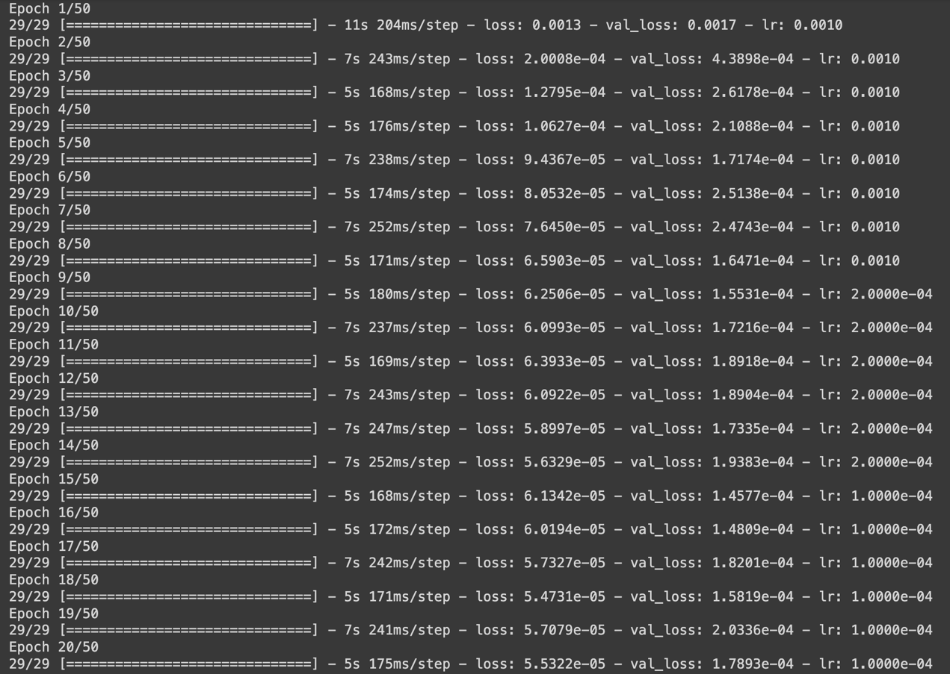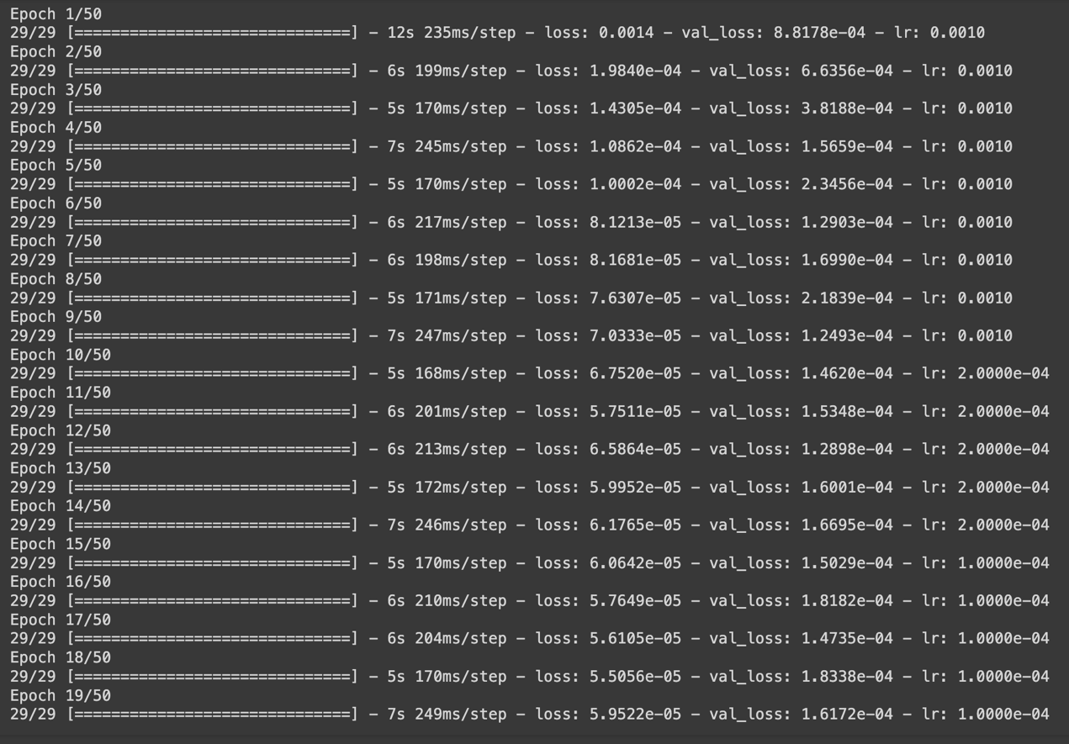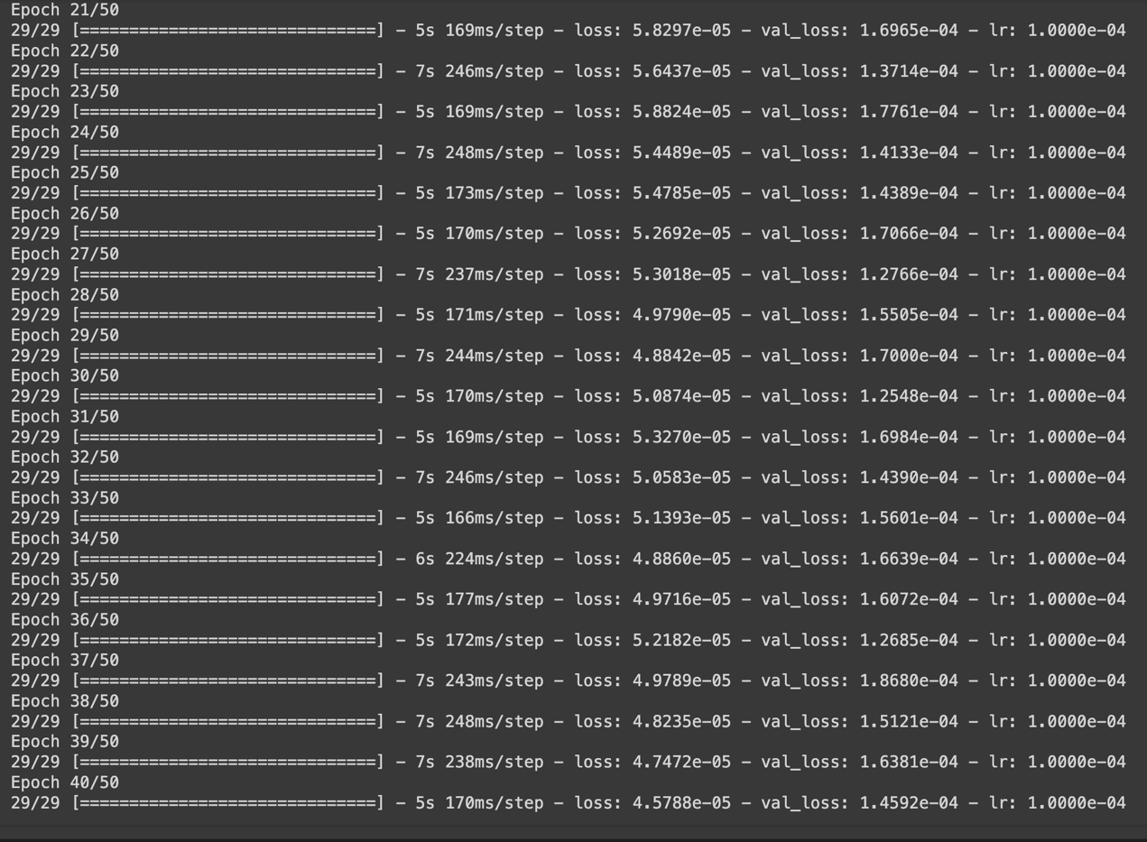 Lstm_units = 100

Dropout_rate = 0.3

Dense_units = 50

Batch_size = 64

Epochs = 50

Learning_rate = 0.001

Dense-1 = tanh

Dense-2 = linear

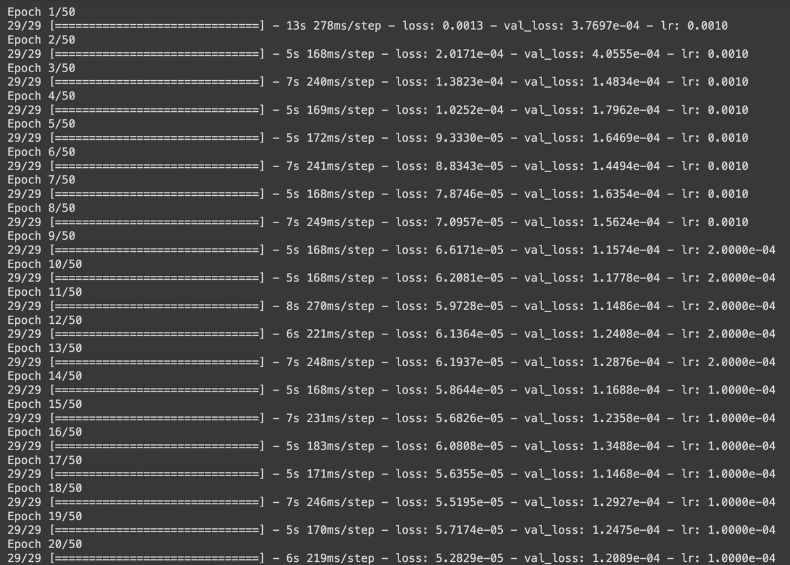

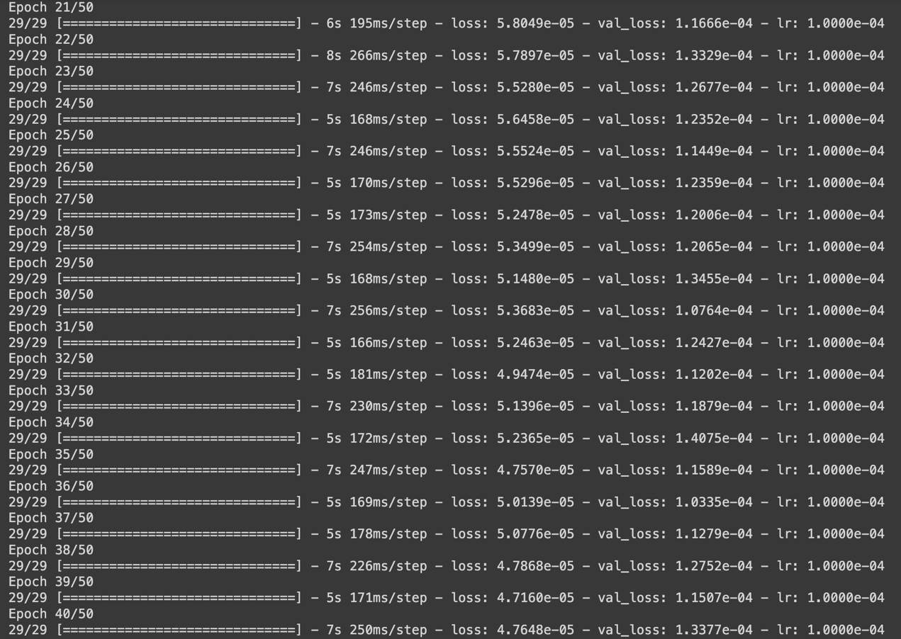

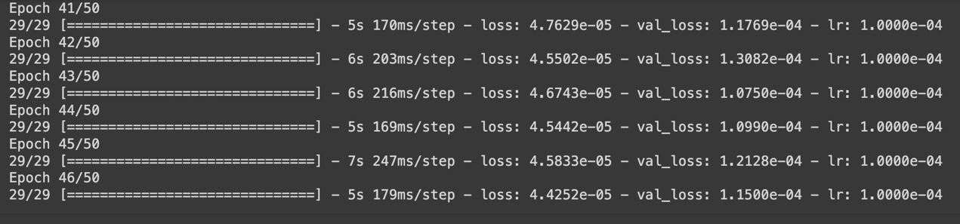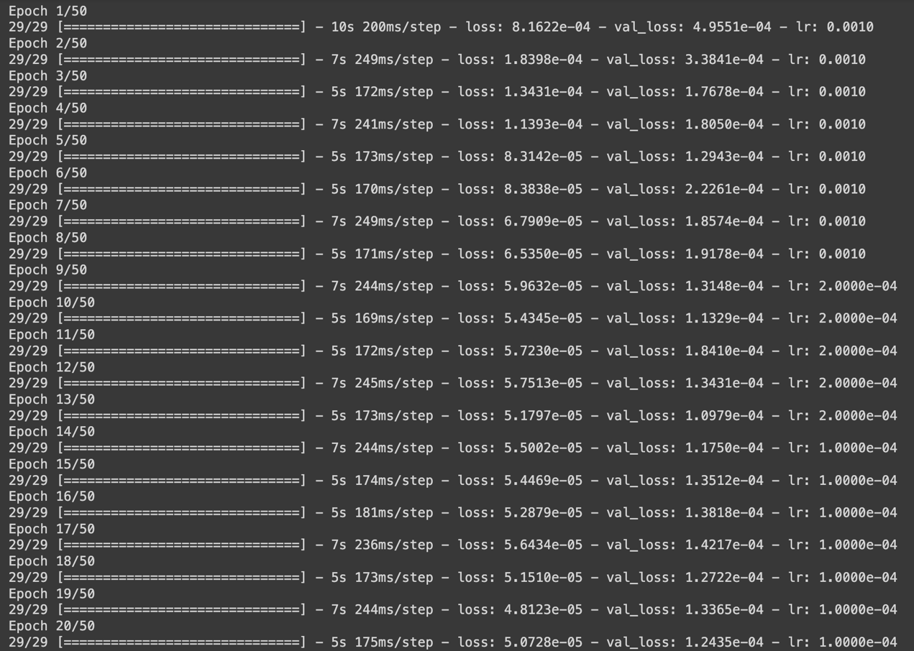 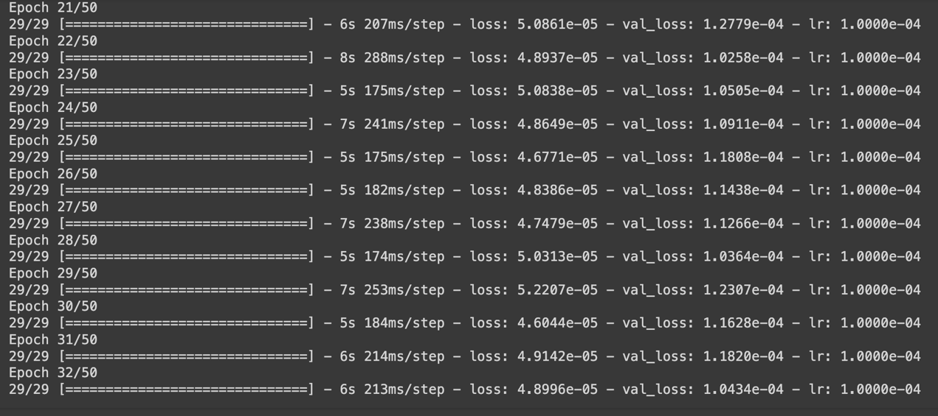

Lstm_units = 100

Dropout_rate = 0.3

Dense_units = 50

Batch_size = 64

Epochs = 50

Learning_rate = 0.001

Dense-1 = exponential

Dense-2 = linear

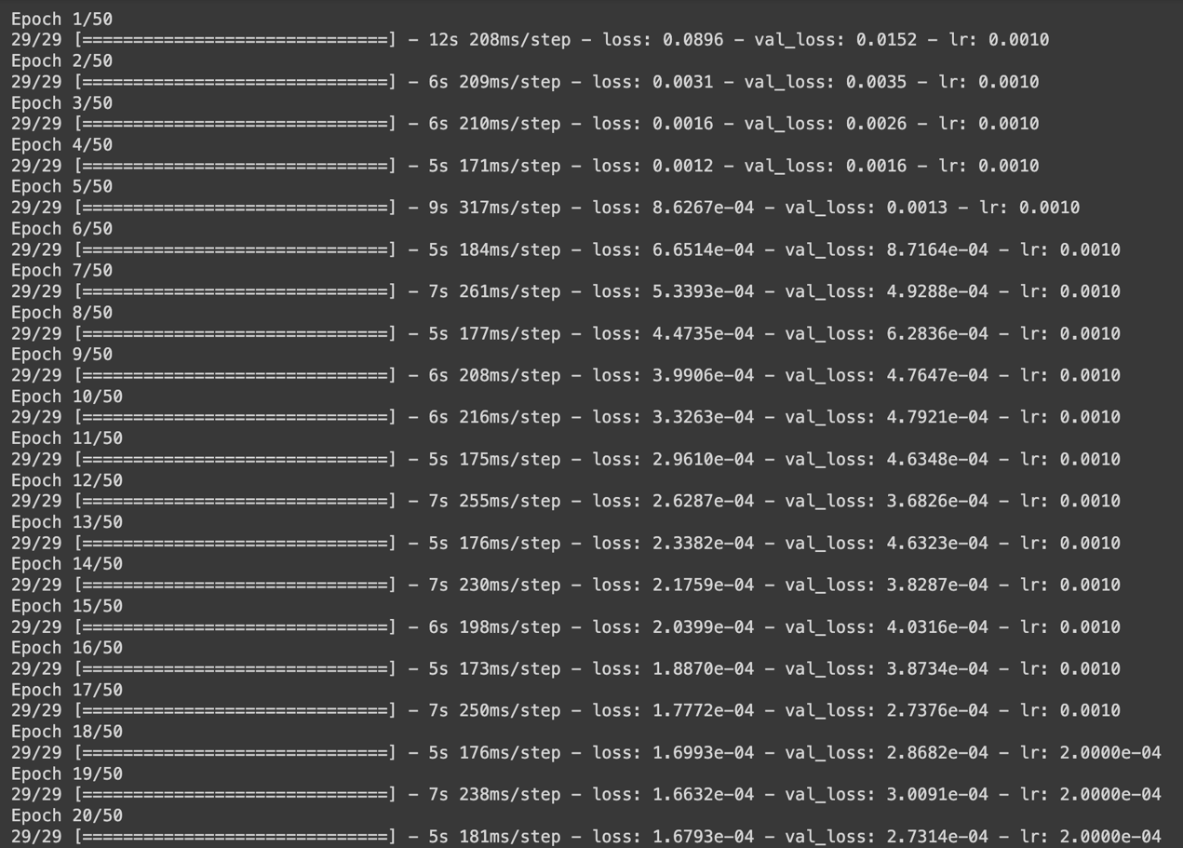

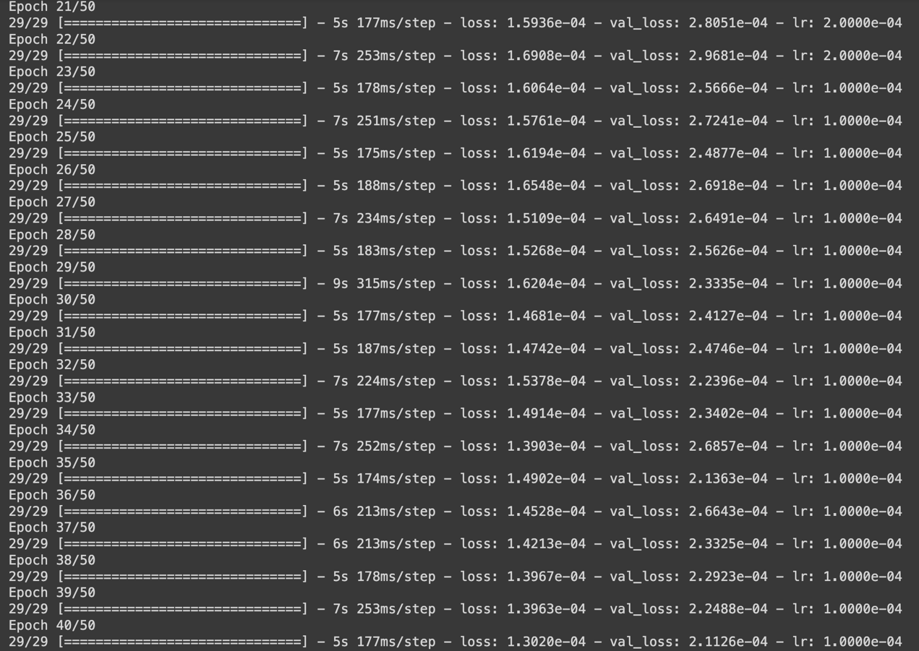

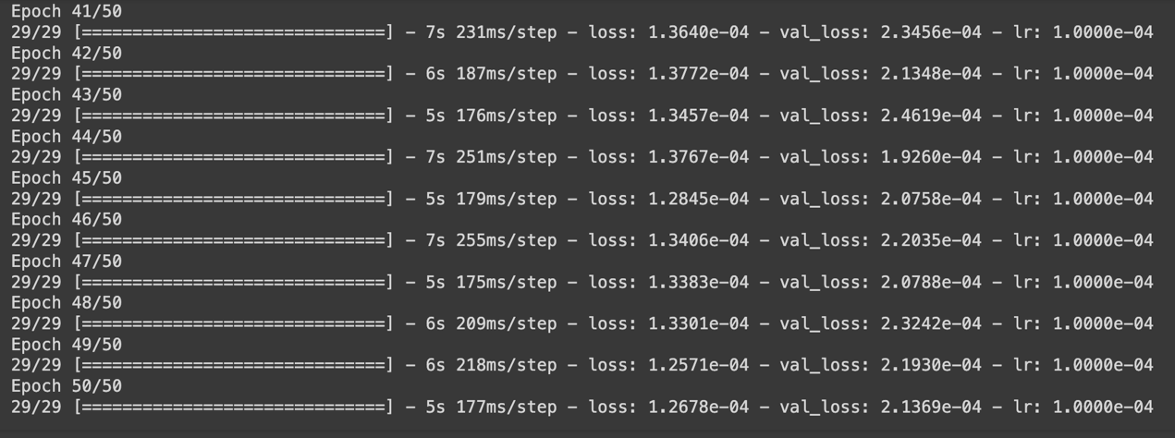

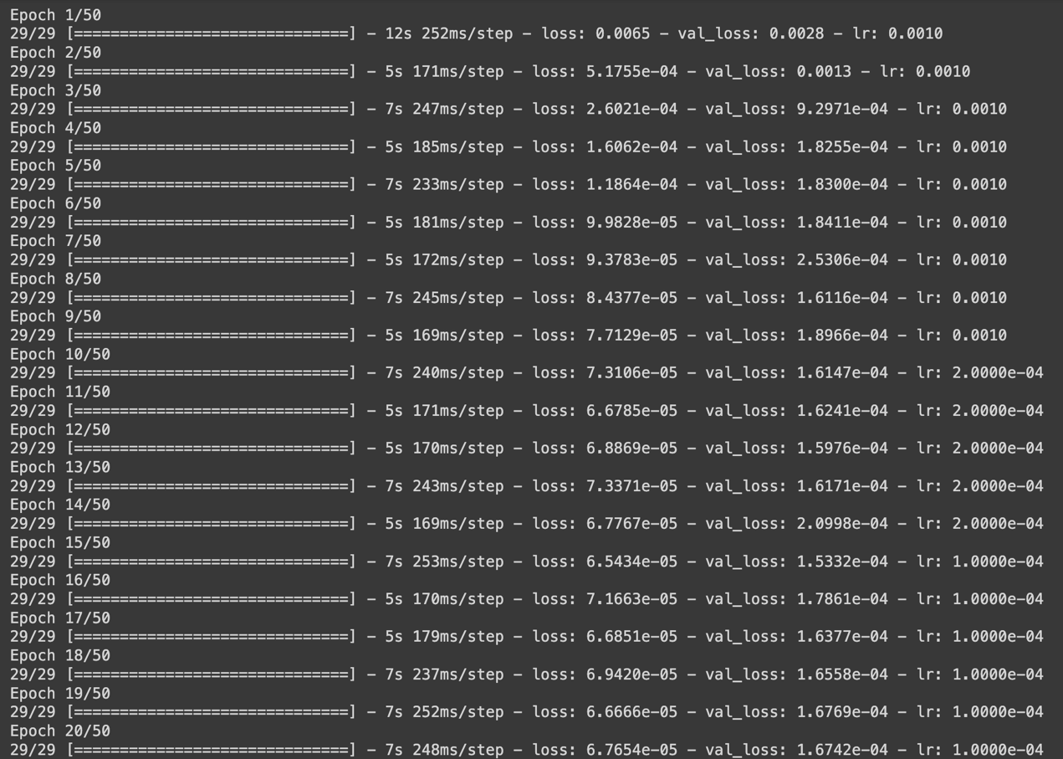

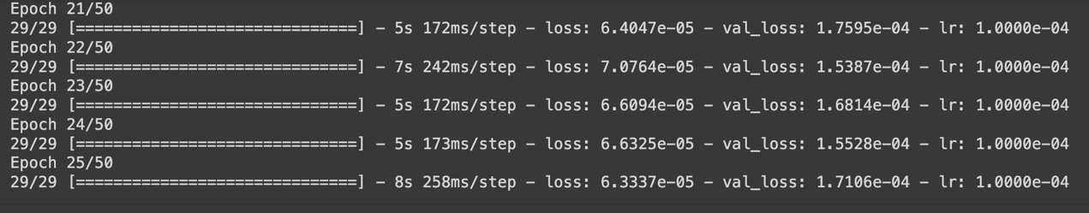 Lstm_units = 100

Dropout_rate = 0.3

Dense_units = 50

Batch_size = 64

Epochs = 50

Learning_rate = 0.001

Dense-1 = relu6

Dense-2 = linear

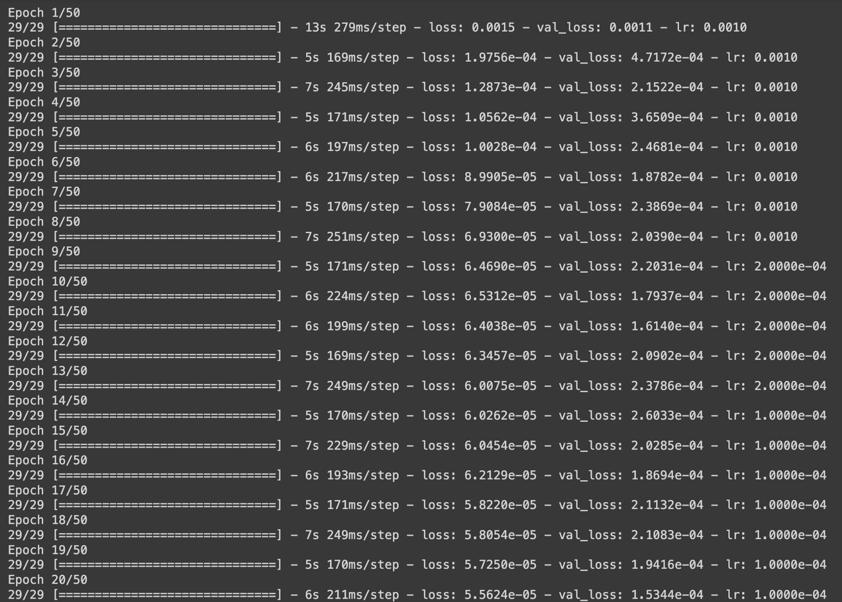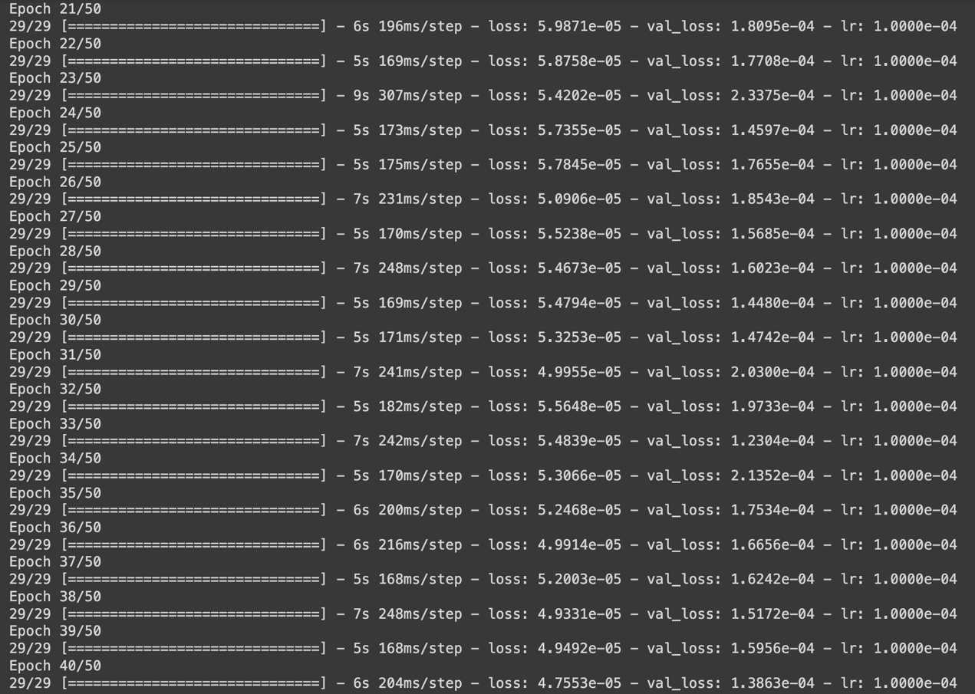

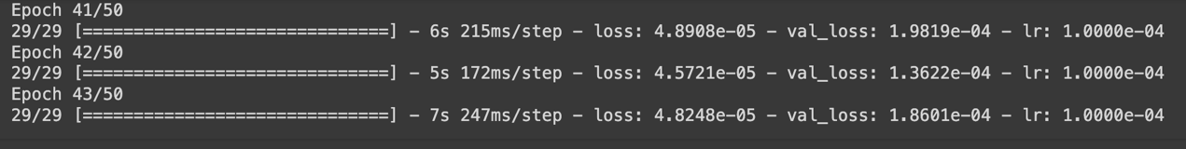

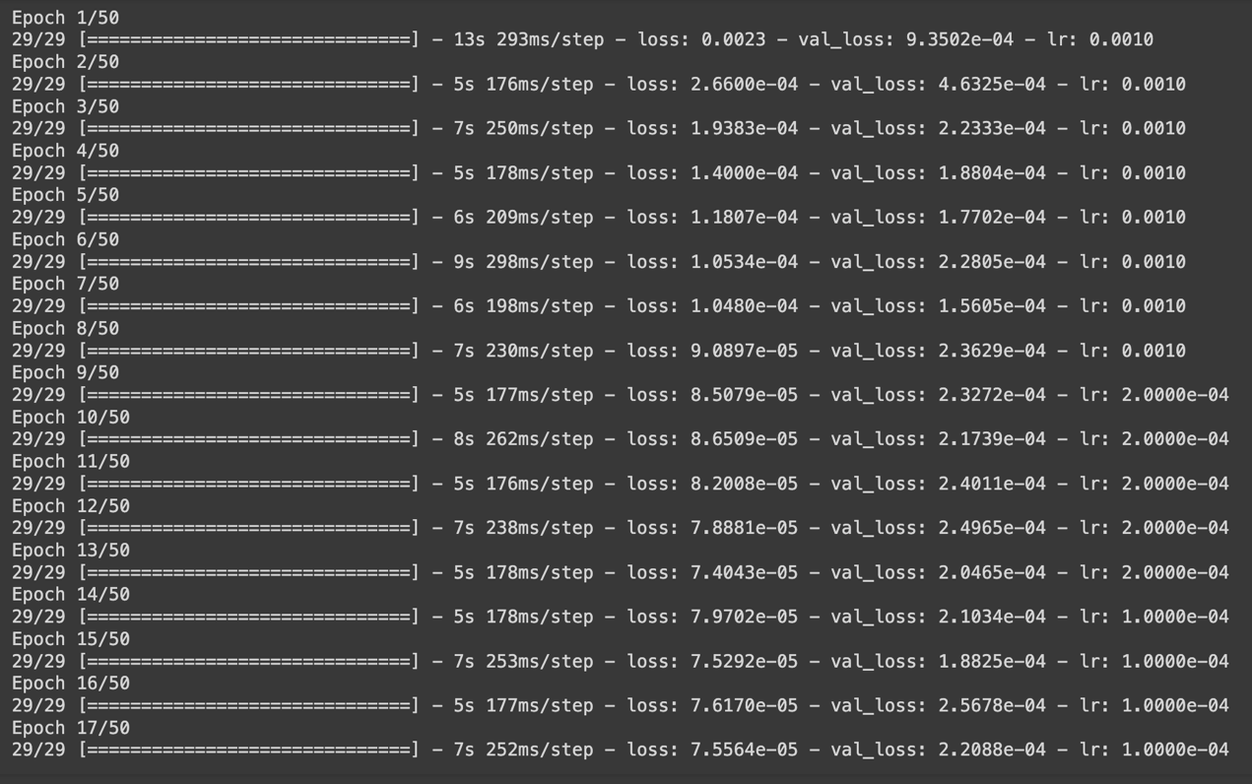 Lstm_units = 100

Dropout_rate = 0.3

Dense_units = 50

Batch_size = 64

Epochs = 50

Learning_rate = 0.001

Dense-1 = silu

Dense-2 = linear

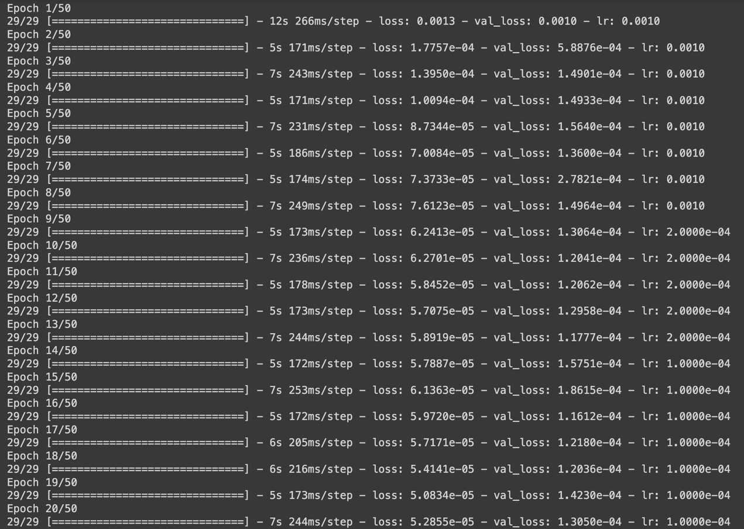

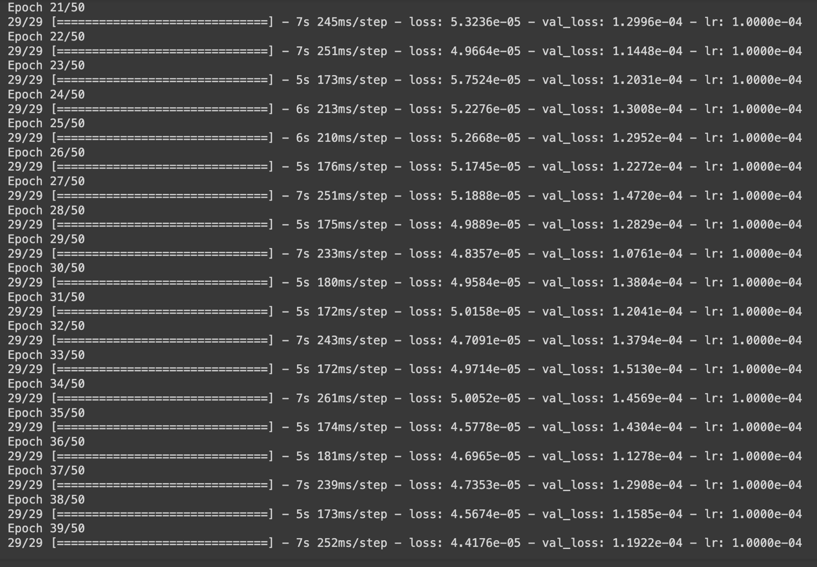

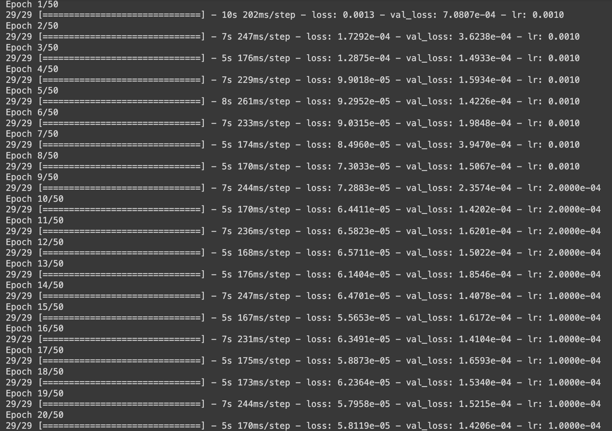

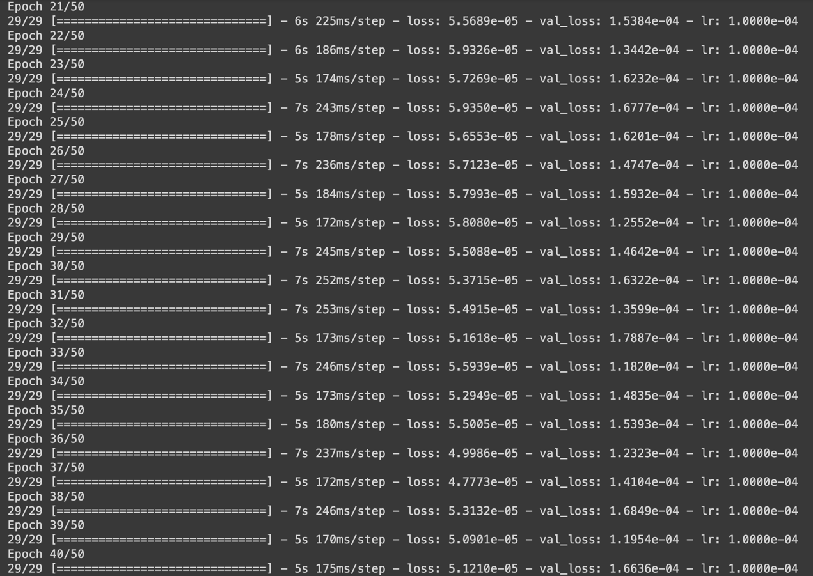

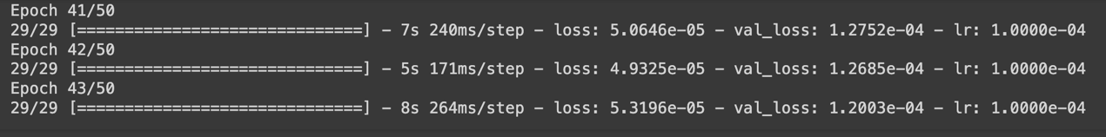

Lstm_units = 100

Dropout_rate = 0.3

Dense_units = 50

Batch_size = 64

Epochs = 50

Learning_rate = 0.001

Dense-1 =gelu

Dense-2 = linear

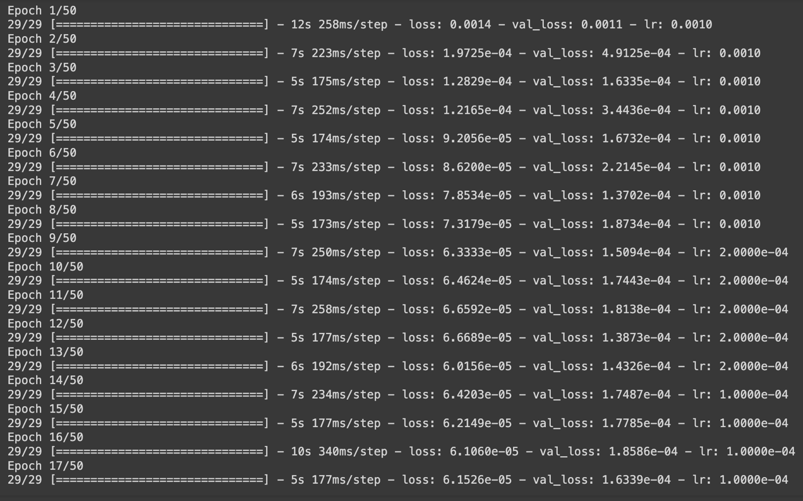

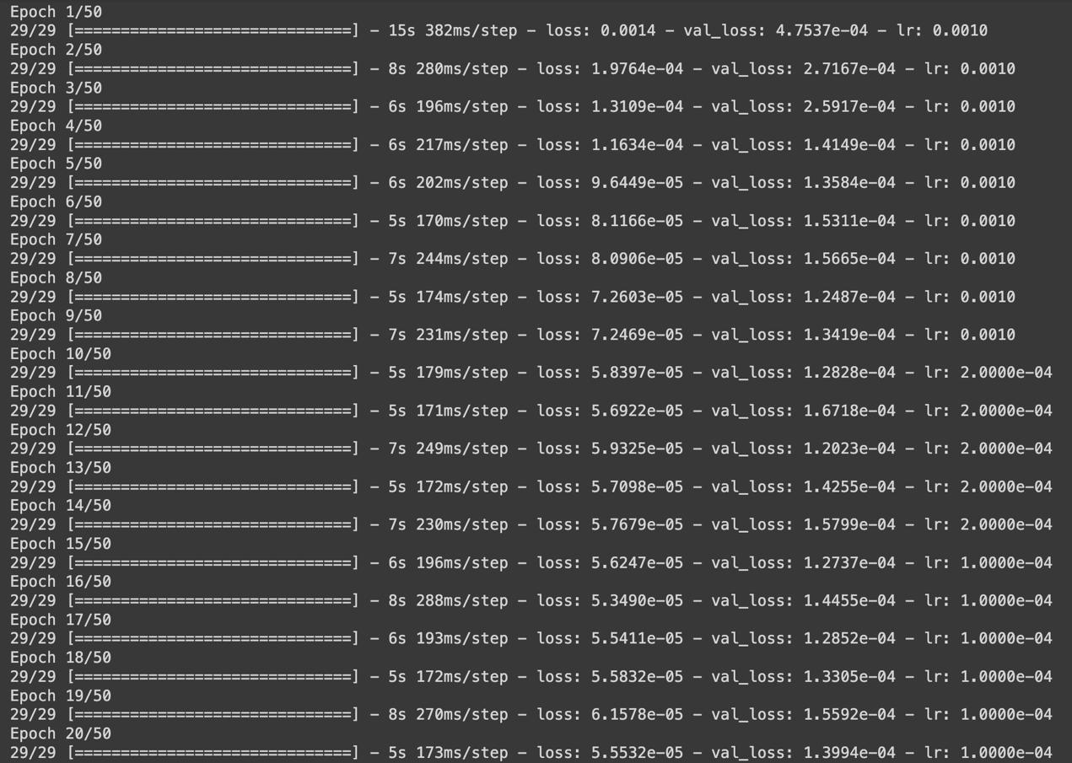



Lstm_units = 100

Dropout_rate = 0.3

Dense_units = 50

Batch_size = 64

Epochs = 50

Learning_rate = 0.001

Dense-1 = linear

Dense-2 = linear

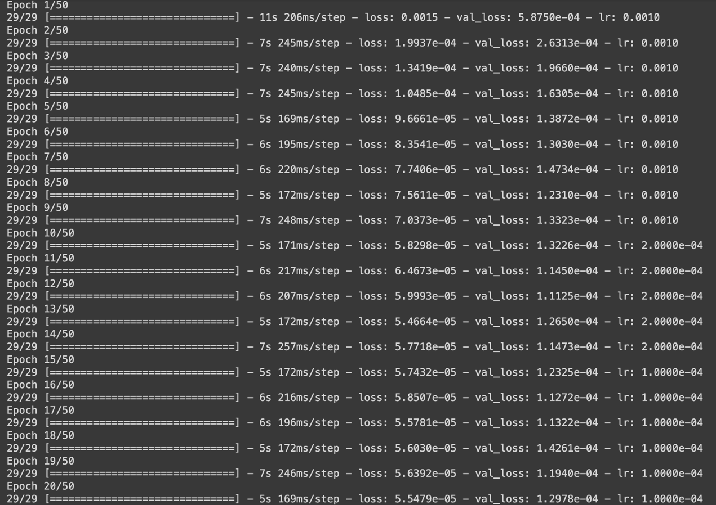



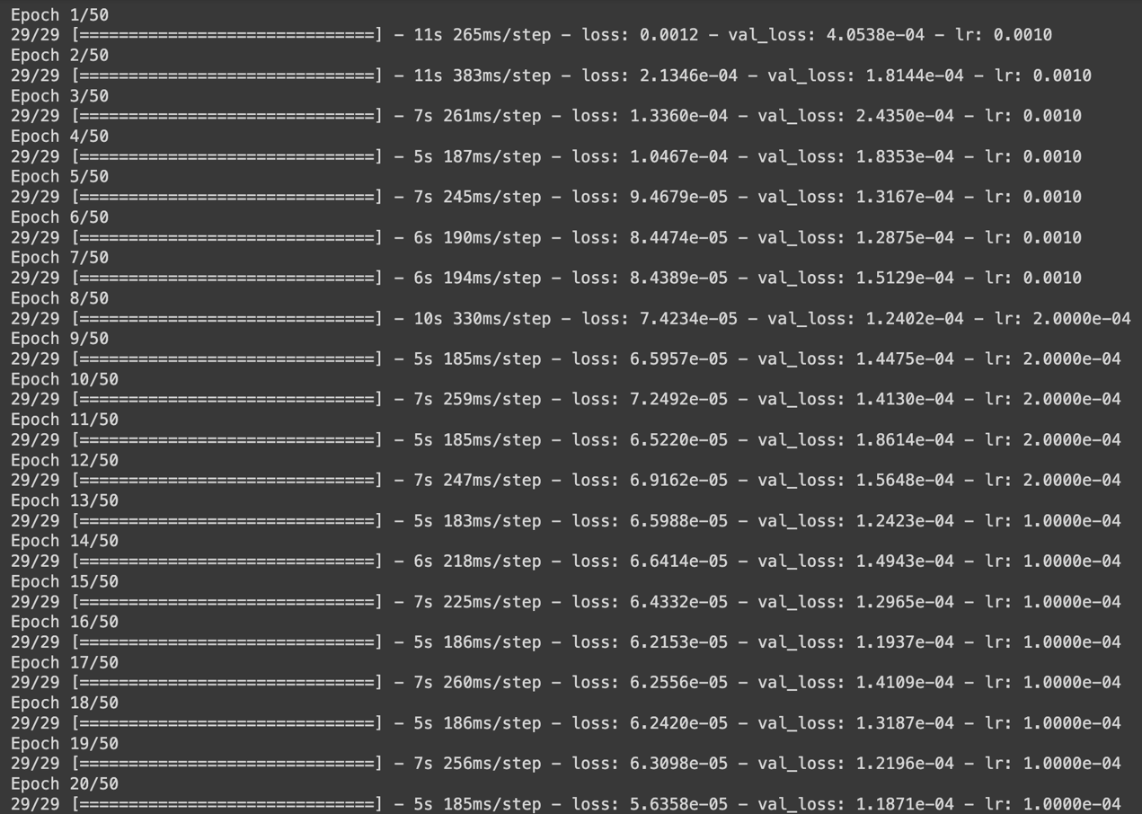

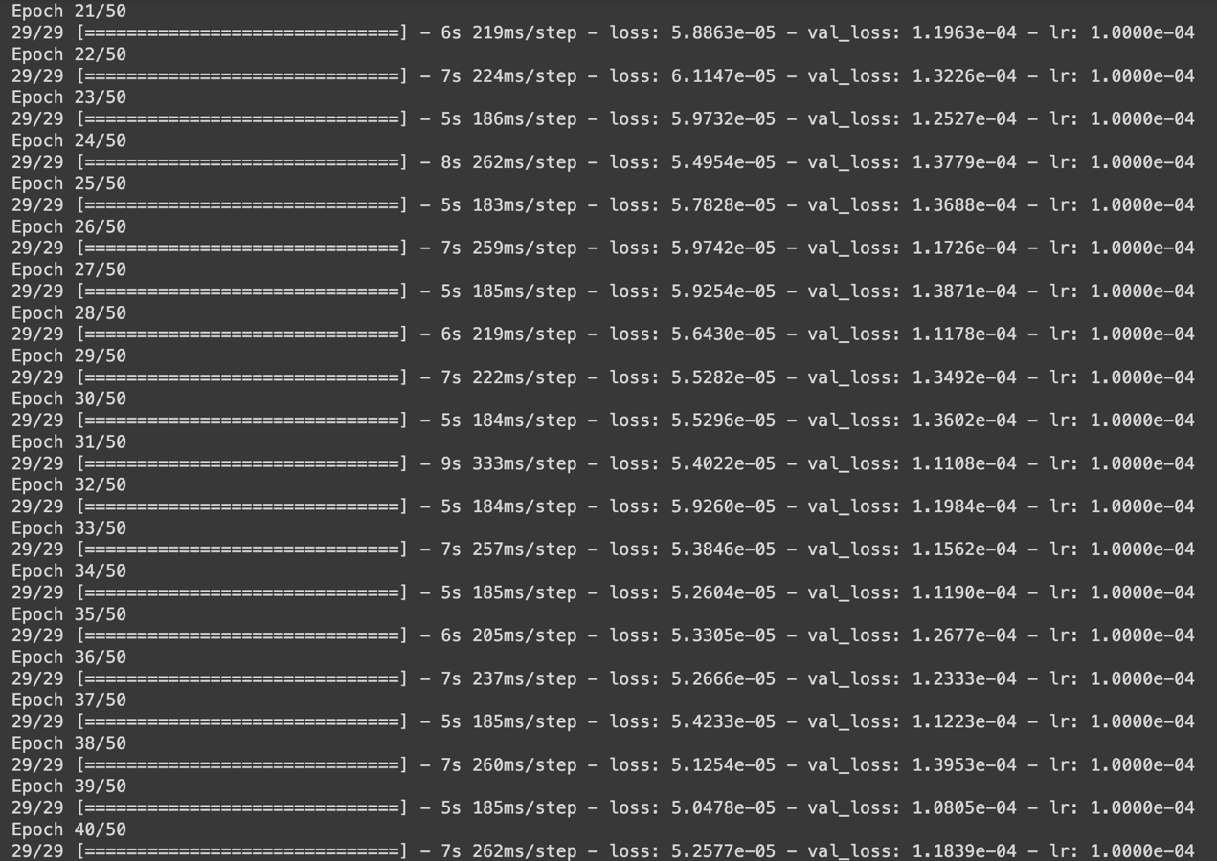

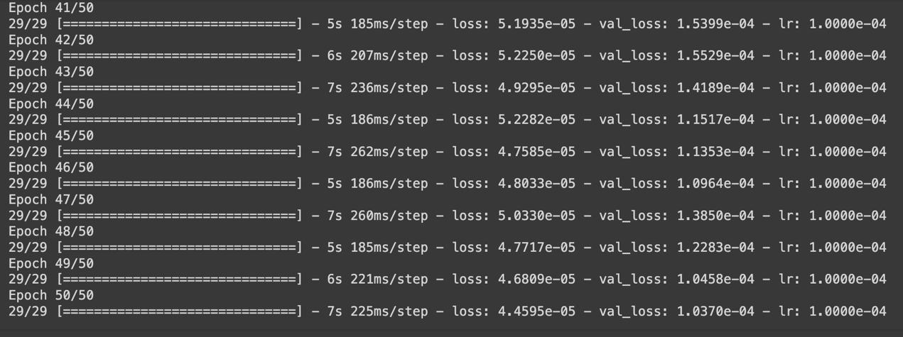

Lstm_units = 100

Dropout_rate = 0.3

Dense_units = 50

Batch_size = 64

Epochs = 50

Learning_rate = 0.001

Dense-1 = mish

Dense-2 = linear

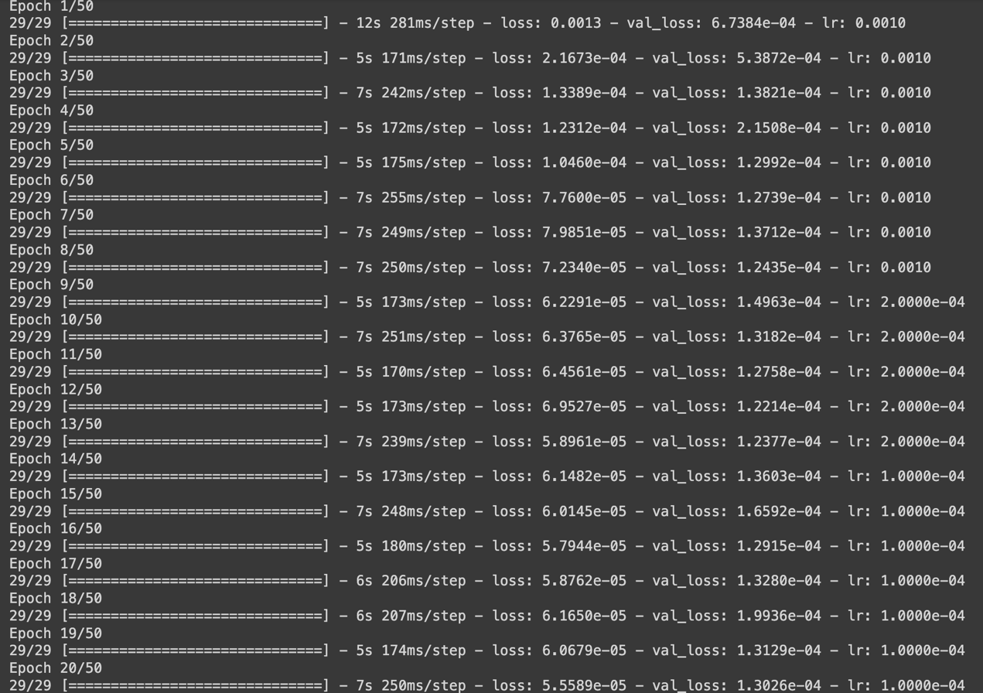



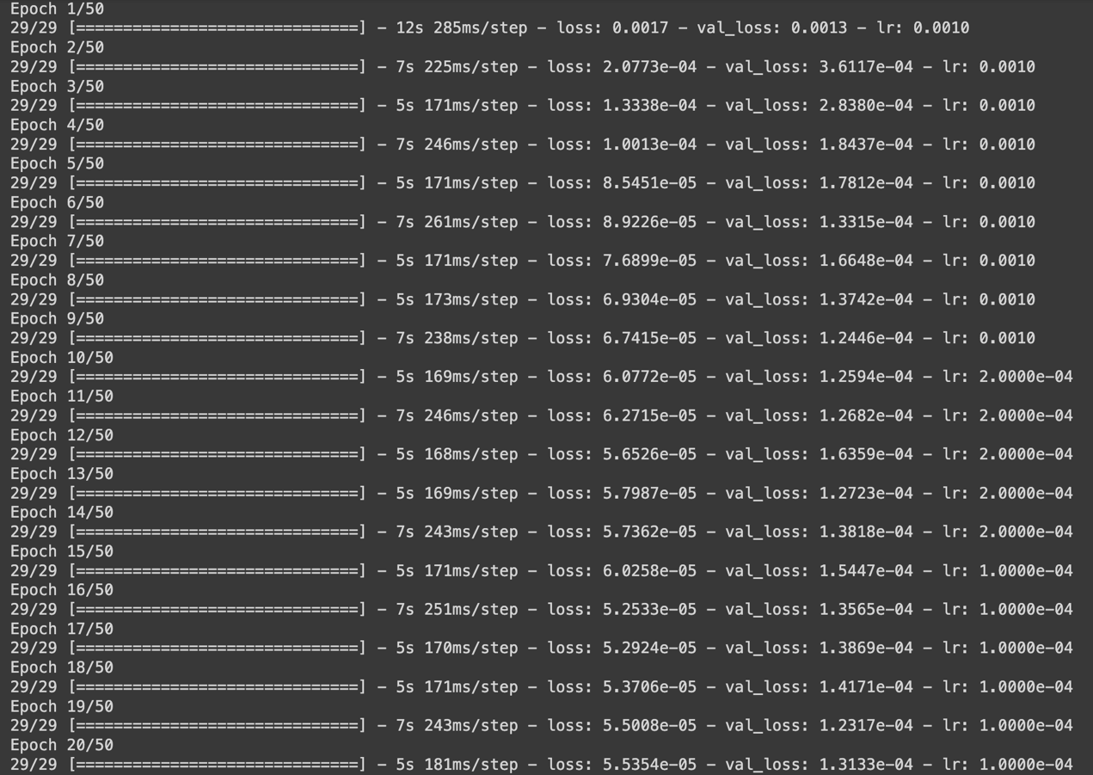

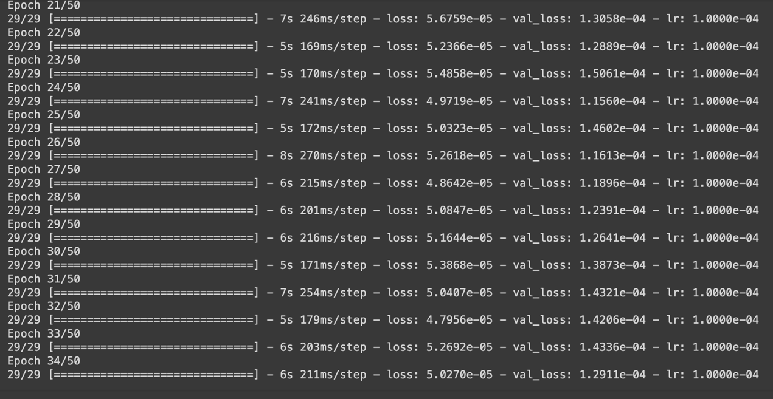

因為做到後面我才覺得有些東西訓練兩次搞不好有機會比較準確，所以有些東西有訓練兩次而有些沒有，就是因為我覺得前面某些部分還要再重新訓練可能會有點亂，最後就決定不用前面的了，不過我不確定連續重新訓練那個模型會不會記憶前面的訓練成果，讓後面在訓練的時候比較有機會成績看來比較好，還是重新訓練模型就是整個全部從零開始了

最後看起來Dense-1使用

Selu

Softsign

Tanh

Relu6

Silu

Linear

Mish

的情形都是相對較好的，但感覺排不出第一，還有一個exponential其中一個輸出的loss是總體最小的，但是val_loss雖然有到2.多e，不過還是不及其他的1.多e，所以依照val_loss為重的話就只能沒讓他進來